Lecture 5.
Mesenchyme, its differentiation.
Structural characteristics of cellular and none-cellular elements of connective tissue. Classification and histogenesis of connective tissue.
Connective tissue proper. Specialized connective tissues.
Blood.
Bone as an organ.
Types and main stages of osteohistogenesis.
Connective tissue comprises a diverse group of cells within a tissue-speciﬁc extracellular matrix. In general, connective tissue consists of cells and an extracellular matrix (ECM). ECM includes protein ﬁbers
(collagen, elastic, and reticular) and an amorphous component containing specialized molecules (proteoglycans, multiadhesive glycoproteins, and glycosaminoglycans) that constitute the ground substance. Connective tissue forms a vast and continuous compartment throughout the body, bounded by
the basal laminae of the various epithelia and by the basal or external laminae of muscle cells and nerve-supporting cells. Diﬀerent types of connective tissue are responsible for a variety of functions. The functions of the various connective tissues are reﬂected in the types of cells and ﬁbers present within the tissue and the composition of the ground substance in the ECM. For example, in loose connective tissue, many cell types are present (Fig. 5.9). One type, the ﬁbroblast, produces the extracellular ﬁbers that serve a structural role in the tissue. Fibroblasts also produce and maintain the ground substance. Other cell types, such as lymphocytes, plasma cells, macrophages, and eosinophils, are associated with the body’s defense system; they function within the ECM of the tissue. In contrast, bone tissue, another form of connective tissue, contains only a single cell type, the osteocyte. This cell produces the ﬁbers that make up the bulk of bone tissue. A unique feature of bone is that its ﬁ bers are organized in a speciﬁc pattern and become calciﬁ ed to create the hardness associated with this tissue. Similarly, in tendons and ligaments, ﬁbers are the prominent feature of the tissue. These ﬁbers are arranged in parallel array and are densely packed to impart maximum strength. Classiﬁcation of connective tissue is primarily based on the composition and organization of its extracellular components and on its functions. Connective tissue encompasses a variety of tissues with diﬀ ering functional properties but with certain common characteristics that allow them to be grouped together. For convenience, they are classiﬁ ed in a manner that reﬂ ects these features.
Although many functions are attributed to connective tissue, its primary functions include:
- Providing structural support
- Serving as a medium for exchange
- Aiding in the defense and protection of the body
- Forming a site for storage of fat
Bones, cartilage, and the ligaments holding the bones together, as well as the tendons attaching muscles to bone, act as support. Similarly, the connective tissue that forms the capsules encasing organs and the stroma forming the structural framework within organs has support functions. Connective tissue also functions as a medium for exchange of metabolic waste, nutrients, and oxygen between the blood and many of the cells of the body. The functions of defense and protection are carried out by (1) the body's phagocytic cells, which engulf and destroy cellular debris, foreign particles, and microorganisms; (2) the body's immunocompetent cells, which produce antibodies against antigens; and (3) certain cells that produce pharmacological substances that help in controlling inflammation. Connective tissues also help protect the body by forming a physical barrier to invasion by and dissemination of microorganisms.
EMBRYONIC CONNECTIVE TISSUE. Embryonic mesenchyme gives rise to the various connective tissues of the body. Mesoderm, the middle embryonic germ layer, gives rise to almost all of the confrom ectoderm by way of the neural crest cells. Through proliferation and migration of the mesodermal and speciﬁ c neural crest cells, a primitive connective tissue referred to as mesenchyme (in the head region, it is sometimes called ectomesenchyme) is established in the early embryo. Maturation and proliferation of the mesenchyme give rise not only to the various connective tissues of the adult but also to muscle, the vascular and urogenital systems, and the serous membranes of the body cavities. The manner in which the mesenchymal cells proliferate and organize sets the stage for the kind of mature connective tissue that will form at any speciﬁc site.Embryonic connective tissue is present in the embryo and within the umbilical cord. Embryonic connective tissue is classiﬁ ed into two subtypes: Mesenchyme is primarily found in the embryo. It contains small, spindle-shaped cells of relatively uniform appearance (Fig. 5.1). Processes extend from these cells and contact similar processes of neighboring cells, forming a three-dimensional cellular network. Gap junctions are present where the processes make contact. The extracellular space is occupied by a viscous ground substance. Collagen and reticular ﬁbers are present; they are very ﬁ ne and relatively sparse. The paucity of collagen ﬁ bers is consistent with the limited physical stress on the growing fetus. Mucous connective tissue is present in the umbilical cord. It consists of a specialized, almost gelatin-like ECM composed mainly of hyaluronan; its ground substance is frequently referred to as Wharton’s jelly. The spindle-shaped cells are widely separated and appear much like ﬁ broblasts in the near-term umbilical cord (e.g., the cytoplasmic processes are thin and di ﬃ cult to visualize in routine hematoxylin and eosin [H&E] preparation). Wharton’s jelly occupies large intercellular spaces located between thin, wispy collagen ﬁbers .

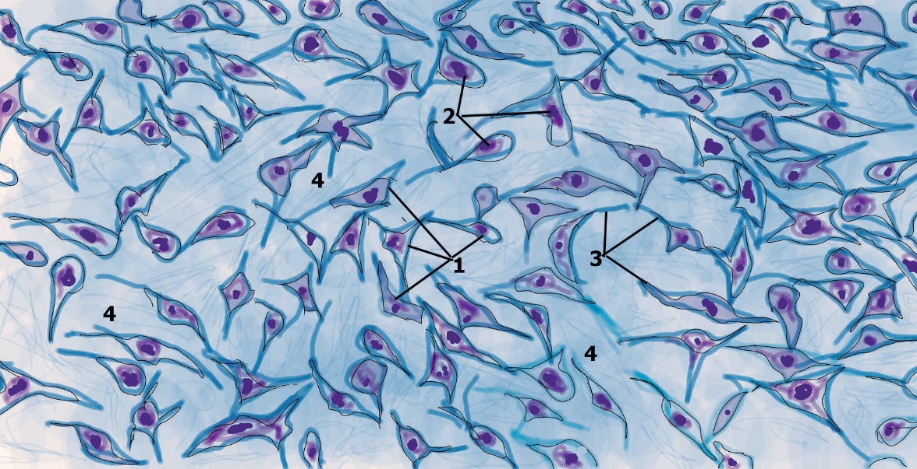

Fig. 5.1

Connective tissue, as the name implies, forms a continuum with epithelial tissue, muscle, and nervous tissue as well as with other components of connective tissues to maintain a functionally integrated body. Most connective tissues originate from mesoderm, the middle germ layer of the embryonic tissue. From this layer, the multipotential cells of the embryo, the mesenchyme, develop, although in certain areas of the head and neck, mesenchyme also develops from neural crest cells of the developing embryo. Mesenchymal cells migrate throughout the body, giving rise to the connective tissues and their cells, including those of bone, cartilage, tendons, capsules, blood and hemopoietic cells, and lymphoid cells (Fig. 5.1). Mature connective tissue is classified as connective tissue proper, the major subject of this chapter, or specialized connective tissue (i.e., cartilage, bone, and blood). Connective tissue is composed of cells and extracellular matrix consisting of ground substance and fibers. The cells are the most important components in some connective tissues, whereas fibers are the most important component in other connective tissue types. For example, fibroblasts are the most important cell component of loose connective tissue because these cells manufacture and maintain the fibers and ground substance composing the extracellular matrix. In contrast, fibers are the most important component of tendons and ligaments. In still other connective tissues, the ground substance is most important component because it is the site where certain specialized connective tissue cells carry out their functions. Thus, all three components are critical to the role of connective tissue function in the body

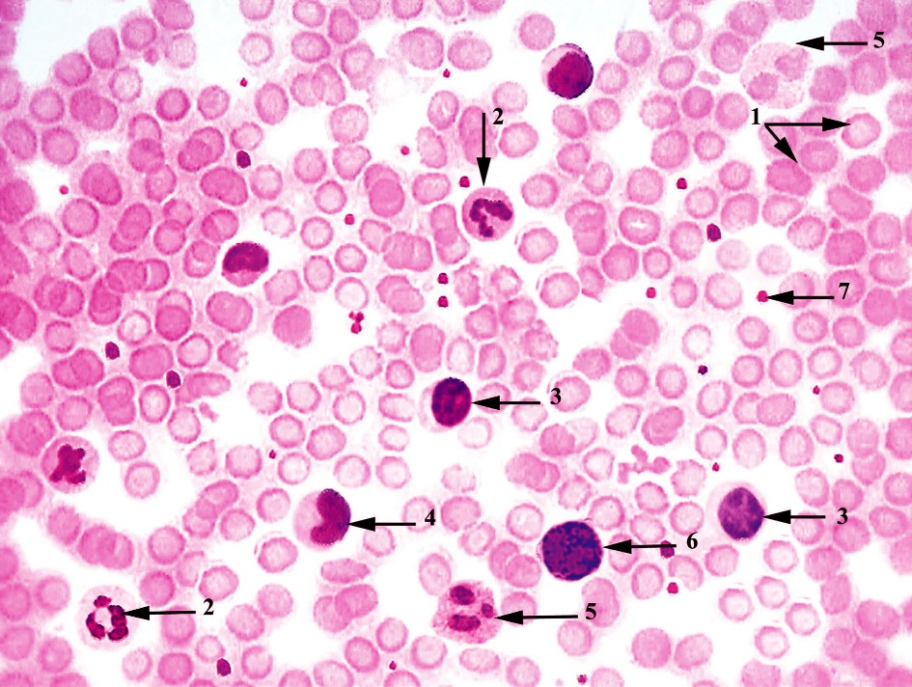

Fig. 5.2

Blood is a bright to dark red, viscous, slightly alkaline fluid (pH, 7.4) that accounts for approximately 7% of the total body weight. The total volume of blood of an average adult is about 5 L, and it circulates throughout the body within the confines of the circulatory system. Blood is a specialized connective tissue composed of formed elements-red blood cells (RBCs; erythrocytes), white blood cells (WBCs; leukocytes), and platelets-suspended in a fluid component (the extracellular matrix), known as plasma (Fig.5.2). Because blood circulates throughout the body, it is an ideal vehicle for the transport of materials. The primary functions of blood include conveying nutrients from the gastrointestinal system to all of the cells of the body and subsequently delivering the waste products of these cells to specific organs for elimination. Numerous other metabolites, cellular products (e.g., hormones and other signaling molecules), and electrolytes are also ferried by the bloodstream to their final destinations. Oxygen (O₂) is carried by hemoglobin within erythrocytes from the lungs for distribution to the cells of the organism, and carbon dioxide (CO₂) is conveyed both by hemoglobin and by the fluid component of plasma (as bicarbonate ion, HCO₃⁻, and in its free form) for elimination by the lungs. Blood also helps to regulate body temperature and to maintain the acid-base and osmotic balance of the body fluids. Finally, blood acts as a pathway for migration of white blood cells between various connective tissue compartments of the body. The fluid state of blood necessitates the presence of a protective mechanism, coagulation, to stop its flow in case of damage to the vascular tree. The process of coagulation is mediated by platelets and blood-borne factors that transform blood from a sol to a gel state. When blood is removed from the body and placed in a test tube, clotting occurs unless the tube is coated with an anticoagulant such as heparin. Upon centrifugation, the formed elements settle to the bottom of the tube as a red precipitate (44%) covered by a thin translucent layer, the buffy coat (1%), and the fluid plasma remains on top as the supernatant (55%). The red precipitate is composed of red blood cells, and the total red blood cell volume is known as the hematocrit; the buffy coat consists of white blood cells and platelets. The finite life span of blood cells requires their constant renewal to maintain a steady circulating population. This process of blood cell formation from established blood cell precursors is called hemopoiesis (also referred to as hematopoiesis). Blood is composed of a fluid component (plasma) and formed elements consisting of the various types of blood cells as well as platelets. Light microscopic examination of circulating blood cells is performed by evenly smearing a drop of blood on a glass slide, air-drying the preparation, and staining it with mixtures of dyes specifically designed to demonstrate distinctive characteristics of the cells. The current methods are derived from the technique developed in the late 19th century by Romanovsky, who used a mixture of methylene blue and eosin. Most laboratories now use either the Wright or Giemsa modifications of the original procedure, and identification of blood cells is based on the colors produced by these stains. Methylene blue stains acidic cellular components blue, and eosin stains alkaline components pink. Still other components are colored a reddish blue by binding to azures, substances formed when methylene blue is oxidized. Plasma Plasma is a yellowish fluid in which cells, platelets, organic compounds, and electrolytes are suspended and/or dissolved. During coagulation, some of the organic and inorganic components leave the plasma to become integrated into the clot. The remaining fluid, which no longer has those components dissolved or suspended in it, differs from plasma, is straw-colored, and is known as serum. The major component of plasma is water, constituting about 90% of its volume. Proteins constitute 9%, and inorganic salts, ions, nitrogenous compounds, nutrients, and gases constitute the remaining 1%. The fluid component of blood leaves the capillaries and small venules to enter the connective tissue spaces as extracellular fluid, which has a composition of electrolytes and small molecules similar to that in plasma. The concentration of proteins in extracellular fluid is much lower than that in plasma, however, because it is difficult even for small proteins, such as albumin, to traverse the endothelial lining of a capillary. In fact, albumin is chiefly responsible for the establishment of blood's colloid osmotic pressure, the force that maintains normal blood and interstitial fluid volumes. Formed Elements Red blood cells, white blood cells, and platelets constitute the formed elements of blood. Erythrocytes. Erythrocytes (red blood cells), the smallest and most numerous cells of blood, have no nuclei and are responsible for the transport of oxygen and carbon dioxide to and from the tissues of the body. Each erythrocyte resembles a biconcave-shaped disk 7.5 μm in diameter, 2.0 μm thick at its widest region, and less than 1 μm thick at its center (Fig. 5.2). This shape provides the cell with a large surface area relative to its volume, thus enhancing its capability for gaseous exchange. Although erythrocyte precursor cells within the bone marrow possess nuclei, during development and maturation the precursor cells or erythrocytes expel not only their nuclei but also all of their organelles before entering the circulation. Thus, mature erythrocytes have no nuclei. When stained with Giemsa or Wright stain, erythrocytes display a salmon-pink color. Although erythrocytes possess no organelles, they do have soluble enzymes in their cytosol. Within the erythrocyte, the enzyme carbonic anhydrase facilitates the formation of carbonic acid from CO₂ and water. This acid dissociates to form bicarbonate (HCO₃⁻) and hydrogen (H⁺). It is as bicarbonate that most of the CO₂ is ferried to the lungs for exhalation. The ability of bicarbonate to cross the erythrocyte cell membrane is mediated by the integral membrane protein band 3, a coupled anion transporter that exchanges intracellular bicarbonate for extracellular chloride; this exchange is known as the chloride shift. Additional enzymes include those of the glycolytic pathway (Embden-Meyerhoff pathway) as well as enzymes that are responsible for the pentose monophosphate shunt (hexose monophosphate shunt) for the production of the high-energy molecule reduced nicotinamide adenine dinucleotide phosphate (NADPH), a reducing agent. The glycolytic pathway does not require the presence of oxygen and is the chief method whereby the erythrocyte produces adenosine triphosphate (ATP), necessary for its energy requirement. Males have more erythrocytes per unit volume of blood than do females (5 × 10⁶ versus 4.5 × 10⁶ per mm³), and members of both sexes living at higher altitudes have correspondingly more red blood cells than residents living at lower altitudes. Human erythrocytes have an average life span of 120 days; when they reach that age, they display on their surface a group of oligosaccharides. Red blood cells bearing these sugar groups are destroyed by macrophages of the spleen, bone marrow, and liver. Hemoglobin Hemoglobin is a large protein composed of four polypeptide chains, each of which is covalently bound to a heme group. Red blood cells are packed with hemoglobin, a large tetrameric protein (68,000 Da) composed of four polypeptide chains, each of which is covalently bound to an iron-containing heme; this molecule is bound within a hydrophobic depression, the heme pocket, of the globin chain which protects the iron from being oxidized while permitting the binding of oxygen to it. It is hemoglobin that provides the unstained cell with its pale yellow color. The globin moiety of hemoglobin releases CO2, and, in regions of high oxygen concentration, such as in the lungs, O2 binds to the iron of each heme. When oxygen is bound to the heme, the hemoglobin molecule is in the relaxed state [(R-) Hb], the globin moieties of the molecule are less constrained and can move with respect to each other, and the O2 can easily be released. When O2 is released, its place becomes occupied by 2,3-diphosphoglycerate and the hemoglobin becomes known as deoxyhemoglobin, or taut hemoglobin [(T-) Hb]. The number of ionic and H bonds between the globin chains of (T-) Hb is greater than that of (R-) Hb, and the movement of the globin chains with respect to each other is reduced. However, in oxygen-poor regions, as in tissues, hemoglobin releases O2 and binds CO2. This property of hemoglobin makes it ideal for the conveyance of respiratory gases. Hemoglobin carrying O2 is known as oxyhemoglobin, and hemoglobin carrying CO2 is called carbaminohemoglobin (or carbamylhemoglobin). Hypoxic tissues release 2,3-diphosphoglyceride, a carbohydrate that facilitates the release of oxygen from the erythrocyte. Hemoglobin also binds nitric oxideView drug information (NO), a neurotrans-mitter substance that causes dilation of blood vessels, permitting red blood cells to release more oxygen and pick up more CO2 within the tissues of the body. On the basis of the amino acid sequences, there are four normal, human polypeptide chains of hemoglobin, designated α, β, γ, and δ. The principal hemoglobin of the fetus, fetal hemoglobin (HbF), composed of two α-chains and two γ-chains, is replaced shortly after birth by adult hemoglobin (HbA). There are two types of normal adult hemoglobin, HbA1 (α2β2) and the much rarer form, HbA2 (α2δ2). In the adult, approximately 96% of the hemoglobin is HbA1, 2% is HbA2, and the remaining 2% is HbF. Leukocytes. Leukocytes are white blood cells that are classified into two major categories: granulocytes and agranulocytes. The number of leukocytes is much smaller than that of red blood cells; in fact, in a healthy adult there are only 6500 to 10,000 white blood cells per mm³ of blood. Unlike erythrocytes, leukocytes do not function within the bloodstream but use it as a means of traveling from one region of the body to another. When leukocytes reach their destination, they leave the bloodstream by migrating between the endothelial cells of the blood vessels (diapedesis), enter the connective tissue spaces, and perform their function. Within the bloodstream as well as in smears, leukocytes are round; in connective tissue, they are pleomorphic. They generally defend the body against foreign substances. White blood cells are classified into two groups: Granulocytes, which have specific granules in their cytoplasm and Agranulocytes, which lack specific granules. Both granulocytes and agranulocytes possess nonspecific (azurophilic) granules, now known to be lysosomes. There are three types of granulocytes, differentiated according to the color of their specific granules after application of Romanovsky-type stains: Neutrophils, Eosinophils, Basophils. There are two types of agranulocytes: Lymphocytes, Monocytes. Neutrophils (Fig. 5.3). Neutrophils compose most of the white blood cell population; they are avid phagocytes, destroying bacteria that invade connective tissue spaces. Polymorphonuclear leukocytes (polys, neutrophils) are the most numerous of the white blood cells, constituting 60% to 70% of the total leukocyte population. In blood smears, neutrophils are 9 to 12 μm in diameter and have a multilobed nucleus. The lobes, connected to each other by slender chromatin threads, increase in number with the age of the cell. In females, the nucleus presents a characteristic small appendage, the "drumstick," which contains the condensed, inactive second X chromosome. It is also called the Barr body or sex chromosome but is not always evident in every cell. Neutrophils are among the first cells to appear in acute bacterial infections. The neutrophil plasmalemma possesses complement receptors as well as Fc receptors for IgG. Neutrophils possess specific, azurophilic, and tertiary granules. Three types of granules are present in the cytoplasm of neutrophils: Small, specific granules (0.1 μm in diameter), Larger azurophilic granules (0.5 μm in diameter), Tertiary granules. Specific granules contain various enzymes and pharmacological agents that aid the neutrophil in performing its antimicrobial functions. In electron micrographs these granules appear somewhat oblong. Azurophilic granules, as already indicated, are lysosomes, containing acid hydrolases, myeloperoxidase, the antibacterial agent lysozyme, bactericidal permeability-increasing (BPI) protein, cathepsin G, elastase, and nonspecific collagenase. Tertiary granules contain gelatinase and cathepsins as well as glycoproteins that are inserted into the plasmalemma. Neutrophils phagocytose and destroy bacteria by using the contents of their various granules. Neutrophils interact with chemotactic agents to migrate to sites invaded by microorganisms.

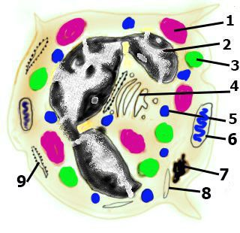

Fig. 5.3

They accomplish this by entering postcapillary venules in the region of inflammation and adhering to the various selectin molecules of endothelial cells of these vessels by use of their selectin receptors. The interaction between the neutrophil's selectin receptors and the selectins of the endothelial cells causes the neutrophils to roll slowly along the vessel's endothelial lining. As the neutrophils are slowing their migrations, interleukin-1 (IL-1) and tumor necrosis factor (TNF) induce the endothelial cells to express intercellular adhesion molecule type 1 (ICAM-1), to which the integrin molecules of neutrophils avidly bind. When binding occurs, the neutrophils stop migrating in preparation for their passage through the endothelium of the postcapillary venule to enter the connective tissue compartment. Once there, they destroy the microorganisms by phagocytosis and by the release of hydrolytic enzymes (and respiratory burst). In addition, by manufacturing and releasing leukotrienes, neutrophils assist in the initiation of the inflammatory process. The sequence of events is:
- 1 The binding of neutrophil chemotactic agents to the neutrophil's plasmalemma facilitates the release of the contents of tertiary granules into the extracellular matrix.
- 2 Gelatinase degrades the basal lamina, facilitating neutrophil migration. Glycoproteins that become inserted in the cell membrane aid the process of phagocytosis.
- 3 The contents of the specific granules are also released into the extracellular matrix, where they attack the invading microorganisms and aid neutrophil migration.
- 4 Microorganisms, phagocytosed by neutrophils, become enclosed in phagosomes Enzymes and pharmacological agents of the azurophilic granules are usually released into the lumina of these intracellular vesicles, where they destroy the ingested microorganisms. Because of their phagocytic functions, neutrophils are also known as microphages to distinguish them from the larger phagocytic cells, the macrophages.
- 5 Bacteria are killed not only by the action of enzymes but also by the formation of reactive oxygen compounds within the phagosomes of neutrophils. These are superoxide (O₂⁻), formed by the action of NADPH oxidase on O₂ in a respiratory burst; hydrogen peroxide (H₂O₂), formed by the action of superoxide dismutase on super-oxide; and hypochlorous acid (HOCl), formed by the interaction of myeloperoxidase (MPO) and chloride ions with hydrogen peroxide.
- 6 Frequently, the contents of the azurophilic granules are released into the extracellular matrix, causing tissue damage, but usually catalase and glutathione peroxidase limit the tissue injury by degrading hydrogen peroxide.
- 7 Once neutrophils perform their function of killing microorganisms, they also die, resulting in the formation of pus, the accumulation of dead leukocytes, bacteria, and extracellular fluid.
- 8 Not only do neutrophils destroy bacteria, they also synthesize leukotrienes from arachidonic acids in their cell membranes. These newly formed leukotrienes aid the initiation of the inflammatory process.
Eosinophils. Eosinophils (Fig. 5.4) phagocytose antigen-antibody complexes and kill parasitic invaders. Eosinophils constitute less than 4% of the total white blood cell population. They are round cells in suspension and in blood smears, but they may be pleomorphic during their migration through connective tissue. Their cell membrane has receptors for immunoglobulin G (IgG), IgE, and complement. Eosinophils are 10 to 14 μm in diameter (in blood smears) and have a sausage-shaped, bilobed nucleus in which the two lobes are connected by a thin chromatin strand and surrounding nuclear envelope. Electron micrographs display a small, centrally located Golgi apparatus, a limited amount of rough endoplasmic reticulum (RER), and only a few mitochondria, usually in the vicinity of the centrioles near the cytocenter. Eosinophils are produced in the bone marrow, and it is interleukin-5 (IL-5) that causes proliferation of their precursors and their differentiation into mature cells Eosinophil Granules The specific granules of eosinophils possess an externum and an internum.. Eosinophils possess specific granules and azurophilic granules. Specific granules are oblong (1.0 to 1.5 μm in length, <1.0 μm in width) and stain deep pink with Giemsa and Wright stains. Electron micrographs show that specific granules have a crystal-like, electron-dense center, the internum, surrounded by a less electron-dense externum. The internum contains major basic protein, eosinophilic cationic protein, and eosinophil-derived neurotoxin, the first two of which are highly efficacious agents in combating parasites. The nonspecific azurophilic granules are lysosomes (0.5 μm in diameter) containing hydrolytic enzymes similar to those found in neutrophils. These function both in the destruction of parasitic worms and in the hydrolysis of antigen-antibody complexes internalized by eosinophils.

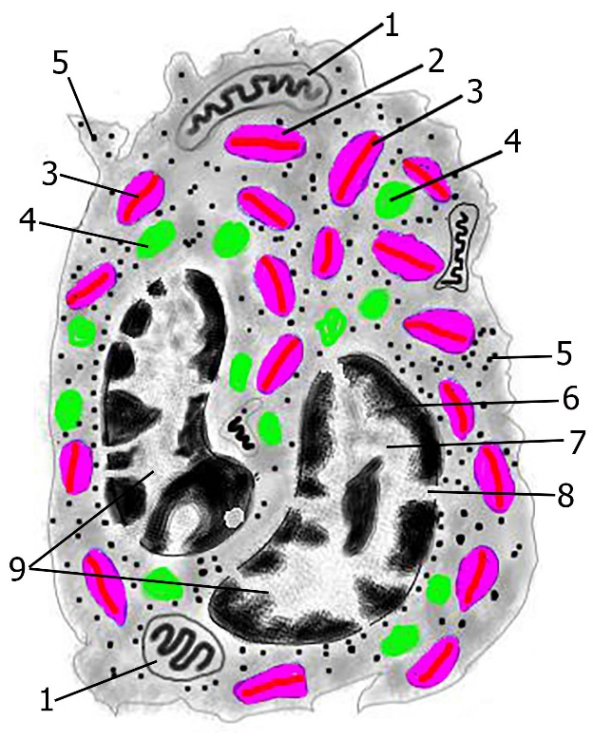
Fig. 5.4

Eosinophils help to eliminate antibody-antigen complexes and to destroy parasitic worms. Eosinophils are associated with these functions:
- Binding of histamine, leukotrienes, and eosinophil chemotactic factor (released by mast cells, basophils, and neutrophils) to eosinophil plasmalemma receptors, which results in the migration of eosinophils to the site of allergic reaction, inflammatory reaction, or parasitic worm invasion
- Degranulation of their major basic protein or eosinophil cationic protein on the surface of parasitic worms, killing them by forming pores in their pellicles, thus facilitating access of agents such as superoxides and hydrogen peroxide to the parasite
- Release of substances that inactivate the pharmacological initiators of the inflammatory response, such as histamine and leukotriene C
- Engulfing of antigen-antibody complexes, which pass into the endosomal compartment for eventual degradation
Basophils (Fig. 5.5). Basophils are similar to mast cells in function even though they have different origins. Basophils constitute less than 1% of the total leukocyte population. They are round cells in suspension but may be pleomorphic during migration through connective tissue. They are 8 to 10 μm in diameter (in blood smears) and have an S-shaped nucleus, which is commonly masked by the large specific granules present in the cytoplasm. In electron micrographs, the small Golgi apparatus, a few mitochondria, extensive RER, and occasional glycogen deposits are clearly evident. Basophils have several surface receptors on their plasmalemma, including immunoglobulin E (IgE) receptors (FcεRI). Basophils possess specific and azurophilic granules. The specific granules of basophils stain dark blue to black with Giemsa and Wright stains. They are approximately 0.5 μm in diameter and frequently press against the periphery of the cell, creating the basophil's characteristic "roughened" perimeter, as seen by light microscopy. The granules contain heparin, histamine, eosinophil chemotactic factor, neutrophil chemotactic factor, neutral proteases, chondroitin sulfate, and peroxidase . The nonspecific azurophilic granules are lysosomes, which contain enzymes similar to those of neutrophils. Basophils function as initiators of the inflammatory process. In response to the presence of some antigens in certain individuals, plasma cells manufacture and release a particular class of immunoglobulin, IgE. The Fc portions of the IgE molecules become attached to the FcεRi of basophils and mast cells without any apparent effect. However, the next time the same antigens enter the body, they bind to the IgE molecules on the surface of these cells.

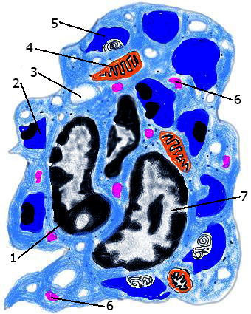

Fig. 5.5

Although mast cells and basophils appear to have similar functions, they are different cells and have different origins. Although the following sequence of steps occurs in both mast cells and basophils, the basophil is used here for descriptive purposes:
- 1 Binding of antigens to the IgE molecules on the surface of a basophil causes the cell to release the contents of its specific granules into the extracellular space.
- 2 In addition, the enzyme phospholipase A generates arachidonic acid residues from the plasma membrane which then are fed into the cyclooxigenase or the lipoxigenase pathway to produce chemical factors that mediate the inflammatory response. These factors are platelet activating factor, leukotriene B₄, prostaglandin D₂, thromboxane A₂, leukotriene C₄, leukotriene D₄, leukotriene E₄ (formerly called slow-reacting substance of anaphylaxis, or SRS-A), adenosine, bradykinin, superoxide, TNF factor α, IL4, IL5, IL6, and granulocyte-monocyte colony-stimulating factor.
- 3 The release of histamine causes vasodilation, smooth muscle contraction (in the bronchial tree), and leakiness of blood vessels.
- 4 Leukotrienes have similar effects, but these actions are slower and more persistent than those associated with histamine. In addition, leukotrienes activate leukocytes, causing them to migrate to the site of antigenic challenge.
Lymphocytes Lymphocytes are agranulocytes and form the second largest population of white blood cells. (Fig. 5.6) Lymphocytes constitute 20% to 25% of the total circulating leukocyte population. They are round cells in blood smears, but they may be pleomorphic as they migrate through connective tissue. Lymphocytes are somewhat larger than erythrocytes, 8 to 10 μm in diameter (in blood smears), and have a slightly indented, round nucleus that occupies most of the cell. The nucleus is dense, rich in heterochromatin, and is acentrically located. The peripherally situated cytoplasm stains a light blue and contains a few azurophilic granules. On the basis of size, lymphocytes may be described as small (8 to 10 μm in diameter), medium (12 to 15 μm), or large (15 to 18 μm), although the latter two are much less numerous . Electron micrographs of lymphocytes display a scant amount of peripheral cytoplasm housing a few mitochondria, a small Golgi apparatus, and a few profiles of RER. A small number of lysosomes, representing azurophilic granules 0.5 μm in diameter, and an abundant supply of ribosomes also are evident . Lymphocytes are subdivided into three functional categories:
- B lymphocytes (B cells)
- T lymphocytes (T cells)
- Null cells.
Although morphologically they are indistinguishable from each other, they can be recognized immunocytochemically by the differences in their surface markers. Approximately 80% of the circulating lymphocytes are T cells, about 15% are B cells, and the remainder are null cells. Their life spans also differ widely: some T cells may live for years, whereas some B cells may die in a few months. In general, B cells are responsible for the humorally mediated immune system, whereas T cells are responsible for the cellularly mediated immune system. Lymphocytes have no function in the bloodstream, but in the connective tissue these cells are responsible for the proper functioning of the immune system. To be immunologically competent, they migrate to specific body compartments to mature and to express specific surface markers and receptors. B cells enter as yet unidentified regions of the bone marrow, whereas T cells migrate to the cortex of the thymus. Once they have become immunologically competent, lymphocytes leave their respective sites of maturation, enter the lymphoid system, and undergo mitosis, forming a group of identical cells, known as a clone. All members of a particular clone can recognize and respond to the same antigen. After stimulation by a specific antigen, both B and T cells proliferate and differentiate into two subpopulations:
- Memory cells do not participate in the immune response but remain as part of the clone with an "immunological memory," ready to undergo cell division and mount a response against a subsequent exposure to a particular antigen or foreign substance.
- Effector cells are classified as B cells and T cells (and their subtypes).

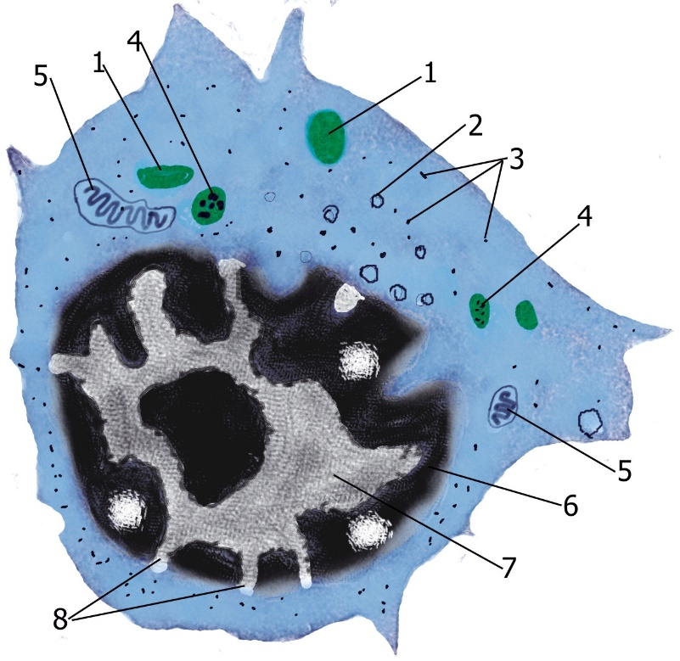

Fig. 5.6

Effector cells are immunocompetent lymphocytes that can perform lymphocyte immune functions; that is, eliminating antigens. B cells are responsible for the humorally mediated immune system; that is, they differentiate into plasma cells, which produce antibodies against antigens. T cells are responsible for the cellularly mediated immune system. Some T cells differentiate into cytotoxic T cells (CTLs; T killer cells), which make physical contact with and kill foreign or virally altered cells. In addition, certain T cells are responsible for the initiation and development (T helper cells) or for the suppression (regulatory T cells, formerly known as T suppressor cells) of most humorally and cellularly mediated immune responses. They accomplish this by releasing signaling molecules known as cytokines (lymphokines) that elicit specific responses from other cells of the immune system . Null cells are composed of two distinct populations:
- Circulating stem cells, which give rise to all of the formed elements of blood
- Natural killer (NK) cells, which can kill some foreign and virally altered cells without the influence of the thymus or T cells.
Monocytes. (Fig.5.7) Monocytes, the largest of the circulating blood cells, enter the connective tissue spaces, where they are known as macrophages. Monocytes are the largest of the circulating blood cells (12 to 15 μm in diameter in blood smears) and constitute 3% to 8% of the leukocyte population. They have a large, acentric, kidney-shaped nucleus that frequently has a "moth-eaten," soap-bubble" appearance and whose lobe-like extensions seem to overlap one another. The chromatin network is coarse but not overly dense, and typically two nucleoli are present, although they are not always evident in smears. The cytoplasm is bluish gray and has numerous azurophilic granules (lysosomes) and occasional vacuole-like spaces . Electron micrographs display both heterochromatin and euchromatin in the nucleus as well as two nucleoli. The Golgi apparatus is usually near the indentation of the kidney-shaped nucleus. The cytoplasm contains deposits of glycogen granules, a few profiles of RER, some mitochondria, free ribosomes, and numerous lysosomes. The periphery of the cell displays microtubules, microfilaments, pinocytotic vesicles, and filopodia. Monocytes stay in circulation for only a few days; they then migrate through the endothelium of venules and capillaries into the connective tissue, where they differentiate into macrophages. Macrophages phagocytose unwanted particular matter, produce cytokines that are required for the inflammatory and immune responses, and present epitopes to T lymphocytes. Macrophages are avid phagocytes and, as members of the mononuclear phagocyte system, they phagocytose and destroy dead and defunct cells (such as senescent erythrocytes) as well as antigens and foreign particulate matter (such as bacteria). The destruction occurs within the phagosomes through both enzymatic digestion and the formation of superoxide, hydrogen peroxide, and hypochlorous acid. Macrophages produce cytokines that activate the inflammatory response as well as the proliferation and maturation of other cells. Certain macrophages, known as antigen-presenting cells, phagocytose antigens and present their most antigenic portions, the epitopes, in conjunction with the integral proteins, class II human leukocyte antigen (class II HLA; also known as major histocompatibility complex antigens [MHC II]), to immunocompetent cells. In response to large foreign particulate matter, macrophages fuse with one another, forming foreign-body giant cells that are large enough to phagocytose the foreign particle.

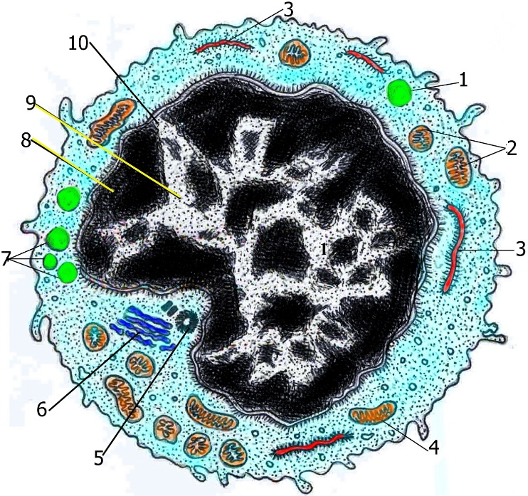

Fig. 5.7

Platelets (Fig. 5.8) Platelets (thromboplastids) are small, disk-shaped, non-nucleated cell fragments derived from megakaryocytes in the bone marrow. Platelets are about 2 to 4 μm in diameter in blood smears. In light micrographs, they display a peripheral clear region, the hyalomere, and a central darker region, the granulomere. The platelet plasmalemma has numerous receptor molecules as well as a relatively thick (15 to 20 nm) glycocalyx. There are between 250,000 and 400,000 platelets per mm³ of blood, each with a life span of less than 14 days. Platelet Tubules and Granules Platelets possess three types of granules (alpha, delta, lambda) as well as two tubular systems (dense and surface opening). Electron micrographs of platelets display 10 to 15 microtubules arranged parallel to each other and forming a ring within the hyalomere. The microtubules assist platelets in maintaining their diskoid morphology. Associated with this bundle of microtubules are actin and myosin monomers, which can rapidly assemble to form a contractile apparatus. In addition, two tubular systems are present in the hyalomere, the surface-opening (connecting) and the dense tubular systems. The surface-opening system is coiled, forming a labyrinthine complex within the platelet. Because this system communicates with the outside, the luminal aspect of this tubular system is a continuation of the outer surface of the platelet, thus increasing the platelet surface area by a factor of seven or eight. The ultrastructure of the granulomere displays the presence of a small number of mitochondria, glycogen deposits, peroxisomes, and three types of granules: alpha granules (a-granules), delta granules (δ-granules), and lambda granules (λ-granules) (lysosomes). The granulomere also houses a system of enzymes that permits platelets to catabolize glycogen, consume oxygen, and generate ATP. If the endothelial lining of a blood vessel is disrupted and platelets come in contact with the subendothelial collagen, they become activated, release the contents of their granules, adhere to the damaged region of the vessel wall (platelet adhesion), and adhere to each other (platelet aggregation). Interactions of tissue factors, plasma-borne factors, and platelet-derived factors form a blood clot. Although the mechanism of platelet aggregation, adhesion, and blood clotting is beyond the scope of histology, some of its salient features are as follows:
- 1 Normally the intact endothelium produces prostacyclins and NO, which inhibit platelet aggregation. It also blocks coagulation by the presence of thrombomodulin and heparin-like molecule on its luminal plasmalemma. These two membrane-associated molecules inactivate specific coagulation factors.
- 2 Injured endothelial cells cease the production and expression of the inhibitors of coagulation and platelet aggregation and they release von Willebrand factor and tissue thromboplastin. They also release endothelin, a powerful vasoconstrictor that reduces the loss of blood.
- 3 Platelets avidly adhere to subendothelial collagen, especially in the presence of von Willebrand factor, release the contents of their granules, and adhere to one another. These three events are collectively called platelet activation.
- 4 The release of some of their granular contents, especially adenosine diphosphate (ADP) and thrombospondin, makes platelets "sticky," causing circulating platelets to adhere to the collagen-bound platelets and to degranulate.
- 5 Arachidonic acid, formed in the activated platelet plasmalemma, is converted to thromboxane A₂, a potent vasoconstrictor and platelet activator.
- 6 The aggregated platelets act as a plug, blocking hemorrhage. In addition, they express platelet factor 3 on their plasmalemma, providing the necessary phospholipid surface for the proper assembly of the coagulation factors (especially of thrombin).
- 7 As part of the complex cascade of reactions involving the various coagulation factors, tissue thromboplastin and platelet thromboplastin both act on circulating prothrombin, converting it into thrombin. Thrombin is an enzyme that facilitates platelet aggregation. In the presence of calcium (Ca²⁺), it also converts fibrinogen to fibrin.
- 8 The fibrin monomers thus produced polymerize and form a reticulum of clot, entangling additional platelets, erythrocytes, and leukocytes into a stable, gelatinous blood clot (thrombus). The erythrocytes facilitate platelet activation, whereas neutrophils and endothelial cells limit both platelet activation and thrombus size.
- 9 Approximately 1 hour after clot formation, actin and myosin monomers form thin and thick filaments, which interact by utilizing ATP as their energy source. As a result, the clot contracts to about half its previous size, pulling the cut edges of the damaged vessel closer together and minimizing blood loss.
- 10 When the vessel is repaired, the endothelial cells release plasminogen activators, which convert circulating plasminogen to plasmin, the enzyme that initiates lysis of the thrombus. The hydrolytic enzymes of λ-granules assist in this process.
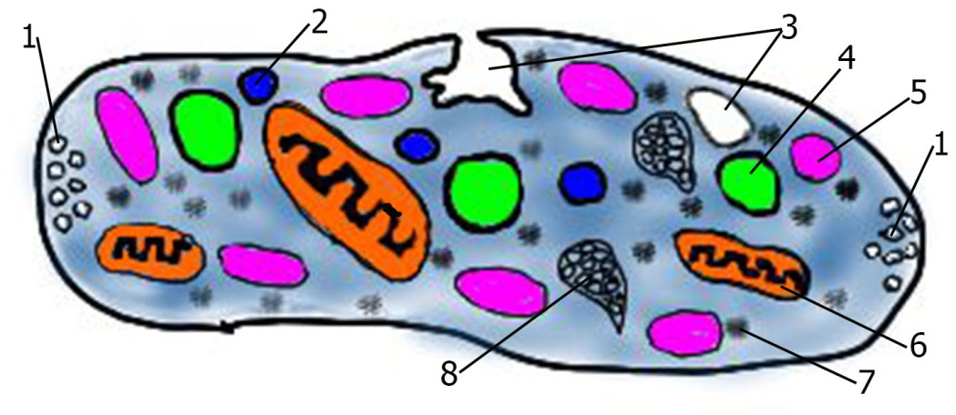
Fig. 5.8

Connective Tissue Proper. The four recognized types of connective tissue proper (loose, dense, and reticular connective tissues and adipose tissue), differ in their histology, location, and functions. Loose (Areolar) Connective Tissue. Loose (areolar) connective tissue is composed of a loose arrangement of fibers and dispersed cells embedded in a gel-like ground substance. Loose connective tissue, also known as areolar connective tissue, (Fig. 5.9) fills in the spaces of the body just deep to the skin, lies below the mesothelial lining of the internal body cavity, is associated with the adventitia of blood vessels, and surrounds the parenchyma of glands. The loose connective tissue of mucous membranes (as in the alimentary canal) is called the lamina propria. Loose connective tissue is characterized by abundant ground substance and tissue fluid (extracellular fluid) housing the fixed connective tissue cells: fibroblasts, adipose cells, macrophages, and mast cells as well as some undifferentiated cells. Also scattered throughout the ground substance are loosely woven collagen, reticular, and elastic fibers. Coursing in this amorphous tissue are small nerve fibers as well as blood vessels that supply the cells with oxygen and nutrients. Because this tissue lies immediately beneath the thin epithelia of the digestive and respiratory tracts, this is where the body first attacks antigens, bacteria, and other foreign invaders. Therefore, loose connective tissue contains many transient cells responsible for inflammation, allergic reactions, and the immune response. These cells, which originally circulate in the bloodstream, are released from blood vessels in response to an inflammatory stimulus. Pharmacological agents released by mast cells increase the permeability of small vessels so that excess plasma enters the loose connective tissue spaces, causing it to swell.

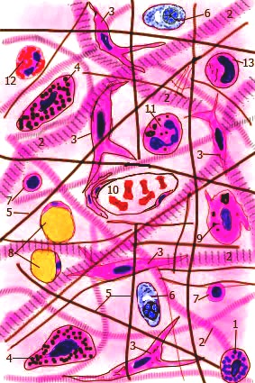

Fig.. 5.9

Fibroblasts (Fig. 5.10 I) Fibroblasts, the most abundant cell type in the connective tissue, are responsible for the synthesis of almost all of the extracellular matrix. Fibroblasts, the most abundant and most widely distributed resident cells of connective tissue, are derived from undifferentiated mesenchymal cells and synthesize the extracellular matrix of connective tissue . Fibroblasts are the least specialized of the cells making up connective tissue and may even be represented by several different functioning populations within certain areas of the body. Because mature and immature fibroblasts may exist side by side, the immature cells, difficult to distinguish from mysenchymal cells, may-depending upon the signal proteins present-differentiate into other cell members of connective tissue (i.e., fat cells, osteoblasts, chondroblasts and myofibroblasts). Fibroblasts may occur in either an active state or a quiescent state. Some histologists differentiate between them, calling the quiescent cells fibrocytes; Active fibroblasts often reside in close association with collagen bundles, where they lie parallel to the long axis of the fiber . Such fibroblasts are elongated, fusiform cells possessing pale-staining cytoplasm, which is often difficult to distinguish from collagen when stained with hematoxylin and eosin (HE). The most obvious portion of the cell is the darker-stained, large, granular, ovoid nucleus containing a well-defined nucleolus. Electron microscopy reveals a prominent Golgi apparatus and abundant rough endoplasmic reticulum (RER) in the fibroblast, especially when the cell is actively manufacturing matrix, as in wound healing. Actin and α-actinin are localized at the periphery of the cell, whereas myosin is present throughout the cytoplasm. In contrast to active fibroblasts, Inactive fibroblasts (Fig.5.10 IV) are smaller, more ovoid, and possess an acidophilic cytoplasm. Their nucleus is smaller, elongated, and more deeply stained. Electron microscopy reveals sparse amounts of RER but an abundance of free ribosomes.

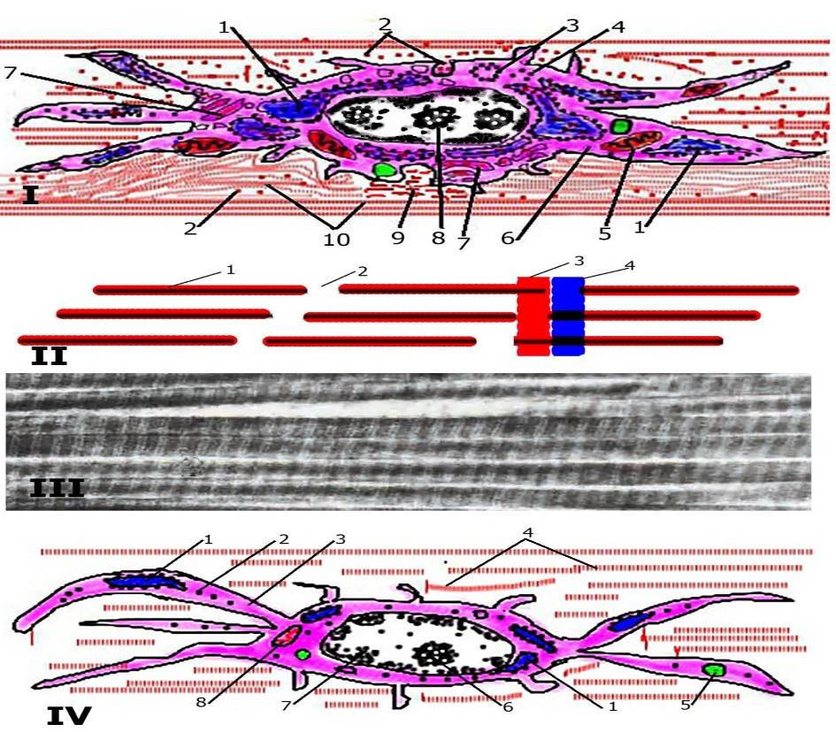

Fig. 5.10

Macrophages belong to the mononuclear phagocytic system and are subdivided into two groups of cells, phagocytes and antigen-presenting cells. As noted earlier, some macrophages behave as fixed cells and some as transient cells. Because macrophages are active phagocytes, they function in removing cellular debris and in protecting the body against foreign invaders. Macrophages measure about 10 to 30 μm in diameter and are irregularly shaped (Fig. 5.11). Their cell surface is uneven, varying from short, blunt projections to finger-like filopodia. More active macrophages have pleats and folds in their plasma membranes as a consequence of cell movement and phagocytosis. Their cytoplasm is basophilic and contains many small vacuoles and small dense granules. The eccentric nucleus of macrophages is smaller and more darkly stained than that of fibroblasts, and it usually does not display nucleoli. The macrophage nucleus is somewhat distinctive in that it is ovoid and usually indented on one side, so that it resembles a kidney. Electron microscopic studies demonstrate a well-developed Golgi apparatus, prominent RER, and an abundance of lysosomes that appear as small, dense granules in light micrographs. As young macrophages mature they increase in size, and there are concomitant increases in RER profiles, Golgi complex, microtubules, lysosomes, microfilaments, and protein synthesis. Histologists once believed that macrophages were derived from precursor cells in the reticuloendothelial system, which included nonphagocytic cells such as reticulocytes. This classification has been replaced by the mononuclear phagocyte system. All members of the mononuclear phagocyte system arise from a common stem cell in the bone marrow, possess lysosomes, are capable of phagocytosis, and display FcεRI receptors and receptors for complement. Monocytes develop in the bone marrow and circulate in the blood. At the proper signal, they leave the bloodstream by migrating through the endothelium of capillaries or venules. In the connective tissue compartment they mature into macrophages, which normally have a life span of about 2 months. Macrophages arise from monocytes, activated by the macrophage colony-stimulating factor (M-CSF). Macrophages localized in certain regions of the body were given specific names before their origin was completely understood. Thus, Kupffer cells of the liver, dust cells of the lung, Langerhans cells of the skin, monocytes of the blood, and macrophages of the connective tissue, spleen, lymph nodes, thymus, and bone marrow are all members of the mononuclear phagocyte system and possess similar morphology and functions. Additionally, osteoclasts of bone and microglia of the brain, although morphologically different, belong to the mononuclear phagocyte system. Under chronic inflammatory conditions, macrophages congregate, greatly enlarge, and become polygonal epithelioid cells. When the particulate matter to be removed is excessively large, several to many macrophages may fuse to form a foreign-body giant cell, a giant multinucleated macrophage. Macrophages residing in the connective tissues were previously called fixed macrophages, and those that developed as a result of an exogenous stimulus and migrated to the particular site were called free macrophages. These names have been replaced by the more descriptive terms resident macrophages and elicited macrophages, respectively. Macrophages phagocytose foreign substances and damaged and senescent cells as well as cellular debris; they also assist in the initiation of the immune response. Macrophages phagocytose senescent, damaged, and dead cells and cellular debris and digest the ingested material through the action of hydrolytic enzymes in their lysosomes. Macrophages also assist in defense of the body by phagocytosing and destroying foreign substances, including microorganisms. During the immune response, factors released by lymphocytes activate macrophages, increasing their phagocytic activity. Activated macrophages vary considerably in shape, possess microvilli and lamellipodia, and exhibit more locomotion compared with unactivated macrophages. Macrophages also play a key role in presenting antigens to lymphocytes.

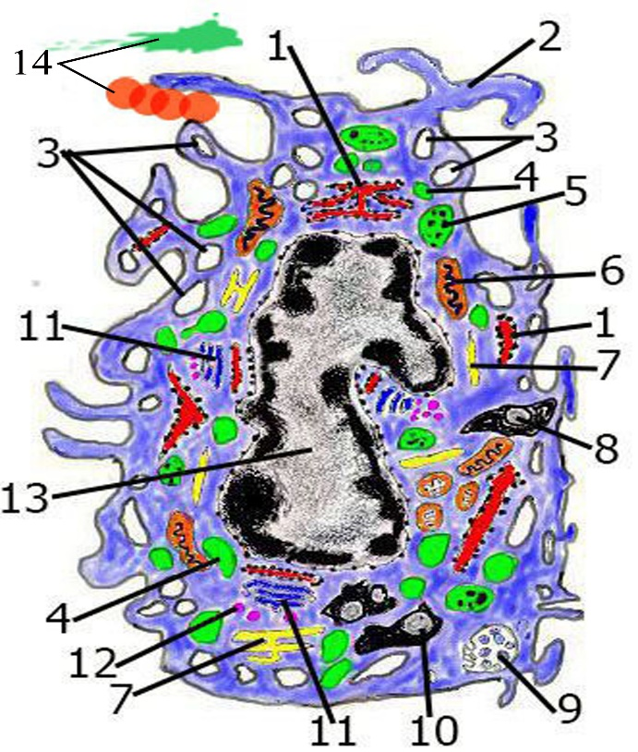

Fig. 5.11

Mast Cells Mast cells arise from bone marrow stem cells and function in mediating the inflammatory process and immediate hypersensitivity reactions. Mast cells (Fig. 5.12), among the largest of the fixed cells of the connective tissue, are 20 to 30 μm in diameter. They are ovoid and possess a centrally placed, spherical nucleus. Unlike the three types of fixed cells discussed earlier, mast cells probably derive from precursors in the bone marrow. The presence of numerous granules in the cytoplasm is the identifying characteristic of mast cells. These membrane-bound granules range in size from 0.3 to 0.8 μm. Because they contain heparin (or chondroitin sulfate), a sulfated glycosaminoglycan, these granules stain metachromatically with toluidine blue (i.e., toluidine blue stains the granules purple). Electron microscopic studies of the granules reveal differences in size and form and display variations in ultrastructure even within the same cell. Otherwise, the cytoplasm is unremarkable; it contains several mitochondria, a sparse number of RER profiles, and a relatively small Golgi complex. In addition to heparin, mast cell granules also contain histamine (or chondroitin sulfates), neutral proteases (tryptase, chymase, and carboxypeptidases), aryl sulfatase (as well as other enzymes, such as γ-glucuronidase, kininogenase, peroxidase, and superoxide dismutase), eosinophil chemotactic factor (ECF), and neutrophil chemotactic factor (NCF). These pharmacological agents present in the granules are referred to as the primary mediators (also known as preformed mediators). Besides the substances found in the granules, mast cells synthesize a number of mediators from membrane arachidonic acid precursors. These newly synthesized mediators include leukotrienes (C₄, D₄, and E₄), thromboxanes (TXA₂ and TXB₂), and prostaglandins (PGD₂). A number of other cytokines are also released that are not arachidonic acid precursors, such as platelet-activating factor (PAF), bradykinins, interleukins (IL-4, IL-5, IL-6), and tumor necrosis factor-alpha (TNF-α). All of these newly synthesized mediators are formed at the time of their release and are collectively referred to as secondary (or newly synthesized) mediators. Because basophils and mast cells share some characteristics, it was once believed that mast cells were basophils that had left the bloodstream to perform their tasks in the connective tissues. It is now known that basophils and mast cells are different cells and have different precursors. Mast cell precursors probably originate in the bone marrow, circulate in the blood for a short time, and then enter the connective tissues, where they differentiate into mast cells and acquire their characteristic cytoplasmic granules. These cells have a life span of less than a few months and occasionally undergo cell division. Mast cells are located throughout the body in the connective tissue proper, where they are concentrated along small blood vessels. They also are present in the subepithelial connective tissue of the respiratory and digestive systems. Mast cells in connective tissue contain mostly heparin in their granules, whereas those located in the alimentary tract mucosa contain chondroitin sulfate instead of heparin. These latter cells are called mucosal mast cells.
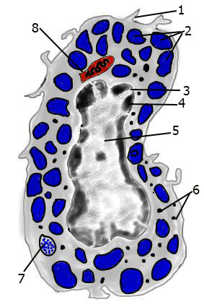

Fig. 5.12

The reason for the existence of the two diverse populations of mast cells is not understood. Furthermore, it has been determined that mast cells vary in phenotype, morphology, histochemistry, mediator content, and response. Thus, phenotypically different mast cell populations are thought to function differently in health and disease. For example, mucosal mast cells release histamine to facilitate the activation of parietal cells of the stomach to produce hydrochloric acid. Mast cells possess high-affinity cell-surface Fc receptors (FceRI) for immunoglobulin E (IgE). They function in the immune system by initiating an inflammatory response known as the immediate hypersensitivity reaction (whose systemic form, known as an anaphylactic reaction, may have lethal consequences). This response commonly is induced by foreign proteins (antigens) such as bee venom, pollen, and certain drugs, as follows:
- 1 The first exposure to any of these antigens elicits formation of IgE antibodies, which bind to the FceRI receptors of the plasmalemma of mast cells, thereby sensitizing these cells.
- 2 On subsequent exposure to the same antigen, the antigen binds to the IgE on the mast cell surface, causing cross-linking of the bound IgE antibodies and clustering of the receptors.
- 3 Cross-linking and clustering activate membrane-bound receptor coupling factors, which in turn initiates at least two independent processes-the release of primary mediators from the granules and synthesis and the release of the secondary mediators from arachidonic acid precursors as well as from other cytoplasmic or membrane lipid sources.
- 4 The release of preformed mediators is accomplished by activation of adenylate cyclase, the enzyme responsible for the conversion of adenosine diphosphate (ADP) to cAMP.
- 5 This increase in cAMP levels activates the release of calcium ion (Ca²⁺) from intracellular storage sites and facilitates an influx from extracellular sources. The resulting increase in cytosolic Ca²⁺ causes the secretory granules to fuse with one another, as well as with the cell membrane. These processes lead to degranulation, the release of the granule contents, namely histamine, heparin, neutral proteases, aryl sulfatase and other enzymes, eosinophil chemotactic factor, and neutrophil chemotactic factor.
- 6 Cross-linking of the membrane-bound IgE also activates phospholipase A₂, which acts on membrane phospholipids to form arachidonic acid.
- 7 Arachidonic acid is converted into the secondary mediators leukotrienes C₄, D₄, and E₄, prostaglandin D₂, and thromboxane A₂. Additionally, the mast cell releases other newly formed pharmacological agents and cytokines. It is important to note that these secondary mediators are not stored in the mast cell granules but are manufactured and immediately released.
Plasma Cells Plasma cells are derived from B lymphocytes and manufacture antibodies. Although plasma cells are scattered throughout the connective tissues, they are present in greatest numbers in areas of chronic inflammation and in areas where foreign substances or microorganisms have entered the tissues.
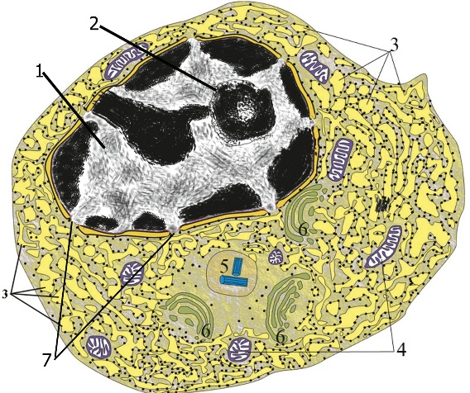

Fig. 5.13

These differentiated cells, which are derived from B lymphocytes that have interacted with antigen, produce and secrete antibodies and are responsible for humorally mediated immunity. Plasma cells (Fig. 5.13) are large, ovoid cells, 20 μm in diameter, with an eccentrically placed nucleus, that have a relatively short life span of 2 to 3 weeks. Their cytoplasm is intensely basophilic as a result of a well-developed RER with closely spaced cisternae. Only a few mitochondria are scattered between the profiles of RER. Electron micrographs display a large, juxtanuclear Golgi complex and a pair of centrioles. In light micrographs, these structures are located in the pale-staining regions adjacent to the nucleus. The spherical nucleus possesses heterochromatin radiating out from the center, giving it a characteristic "clock face" or "spoked" appearance under the light microscope. Adipose Tissue. Adipose tissue is classified into two types according to whether it is composed of unilocular or multilocular adipocytes. Other differences between the two types of adipose tissue are color, vascularity, and metabolic activity. White (Unilocular) Adipose Tissue. Each unilocular fat cell (Fig. 5.14) contains a single lipid droplet, giving the adipose tissue composed of such cells a white color. (In a person whose diet is especially rich in foods containing carotenoids, such as carrots, this adipose tissue is yellow.) White adipose tissue is heavily supplied with blood vessels, which form capillary networks throughout the tissue. The vessels gain access via connective tissue septa that partition the fat into lobules . The plasma membranes of the unilocular adipose cells contain receptors for several substances, including insulin, growth hormone, norepinephrine, and glucocorticoids, that facilitate the uptake and release of free fatty acids and glycerol. Unilocular fat is present in the subcutaneous layers throughout the body. It also occurs in masses in characteristic sites influenced by sex and age. In men, fat is stored in the neck, in the shoulders, about the hips, and in the buttocks. As men age, the abdominal wall becomes an additional storage area. In women, fat is stored in the breasts, buttocks, hips, and lateral aspects of the thighs. Additionally, fat is stored in both sexes in the abdominal cavity about the omental apron and the mesenteries.

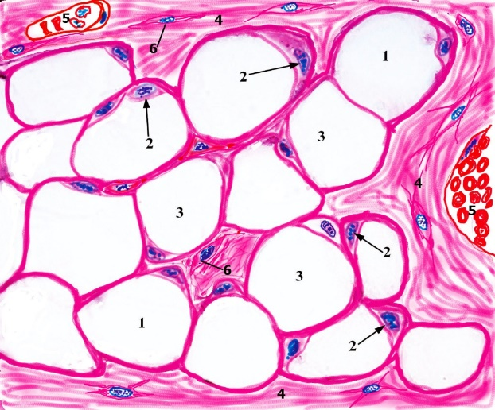

Fig. 5.14

Brown (Multilocular) Adipose Tissue. Brown adipose tissue (brown fat) is composed of multilocular fat cells, which store fat in multiple droplets (Fig. 5.18). This tissue may appear tan to reddish brown because of its extensive vascularity and the chytochromes present in its abundant mitochondria. Multilocular adipose tissue has a lobular organization and vascular supply similar to those of a gland. Brown fat tissue is very vascular because the vessels are located near the adipocytes. Unmyelinated nerve fibers enter the tissue, with the axons ending on the blood vessels as well as on fat cells, whereas in white fat tissue, the neurons end only on the blood vessels. Although it has long been known that multilocular fat is found in many mammalian species, especially those that hibernate, and in the infants of most mammals, it was unclear whether multilocular fat exists in adult humans. However, in the newborn human, brown fat is located in the neck region and in the interscapular region. As humans mature, the fat droplets in brown fat cells coalesce and form into one droplet (similar to the droplets in white fat cells) and the cells become more like those in unilocular fat tissue. Thus, although adults appear to contain only unilocular fat, there is evidence that they also possess brown fat. This feature can be demonstrated in some of the wasting diseases of older people, in which multilocular fat tissue forms again and in the same areas as in the newborn. Brown adipose tissue is associated with production of body heat because of the large number of mitochondria in the multilocular adipocytes composing this tissue. These cells can oxidize fatty acids at up to 20 times the rate of white fat, increasing body heat production three-fold in cold environments. Sensory receptors in the skin send signals to the temperature-regulating center of the brain, resulting in the relaying of sympathetic nerve impulses directly to the brown fat cells. The neurotransmitter norepinephrine activates the enzyme that cleaves triglycerides into fatty acids and glycerol, initiating heat production by oxidation of fatty acids in the mitochondria. Thermogenin, a transmembrane protein located on the inner membrane of mitochondria, permits backflow of protons instead of utilizing them for synthesis of adenosine triphosphate (ATP); as a result of uncoupling oxidation from phosphorylation, the proton flow generates energy that is dispersed as heat. Histogenesis of Adipose Tissue It is believed that adipose cells are derived from undifferentiated embryonic stem cells that develop into preadipocytes, cells that, under the influence of a series of activating factors, differentiate into adipocytes. The predominant view is that adipose tissue develops via two separate processes. In primary fat formation, which occurs early in fetal life, groups of epithelioid precursor cells, probably preadipocytes, are distributed at certain locations in the developing fetus; in these tissues, lipid droplets begin to accumulate in the form of brown adipose tissue. Near the end of fetal life, other fusiform precursor cells differentiate in many areas of the connective tissues within the fetus and begin to accumulate lipids that coalesce into the single droplet in each cell, thus forming the unilocular fat cells found in adults. The latter process has been named secondary fat formation. It should be understood, however, that brown adipose tissue is present in the embryo but white adipose tissue appears only after birth. The endothelial cells lining the lumen of the blood vessel rest on a basal lamina. These flattened cells are elongated into a sheet such that their long axis is more or less parallel to the long axis of the vessel, which permits each endothelial cell to nearly surround the lumen of a small-caliber vessel. In larger-bore vessels, several to many individual endothelial cells are required to line the circumference of the lumen.

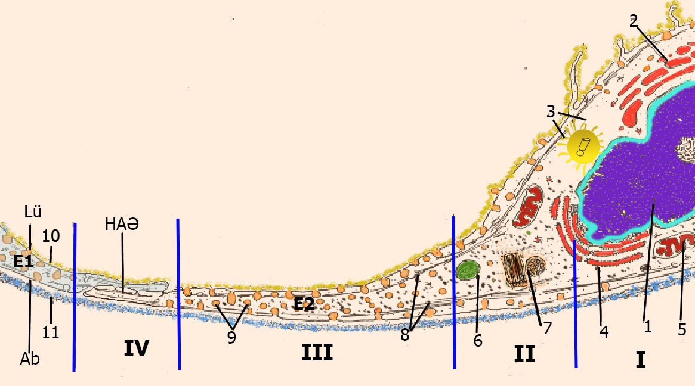

Fig. 5.15

Endothelial cells not only provide an exceptionally smooth surface but also function in secreting types II, IV, and V collagens, lamin, endothelin, nitric oxide, and von Willebrand factor. Moreover, they possess membrane-bound enzymes, such as angiotensin-converting enzyme (ACE), which cleaves angiotensin I to generate angiotensin II, as well as enzymes that inactivate bradykinin, serotonin, prostaglandins, thrombin and norepinephrine; moreover, they also bind lipoprotein lipase, the enzyme that degrades lipoproteins.. Capillaries are formed by a single layer of squamous endothelial cells rolled into a tube, with the long axis of these cells lying in the same direction as the blood flow. These endothelial cells are flattened, with the attenuated ends tapering to a thickness to 0.2 μm or less, although an elliptical nucleus bulges out into the lumen of the capillary. The cytoplasm contains a Golgi complex, a few mitochondria, some rough endoplasmic reticulum (RER), and free ribosomes (Fig. 5.15). Intermediate filaments (9 to 11 nm in diameter), located around the perinuclear zone, vary in filament composition. For example, some cells contain filaments composed of desmin, others contain filaments composed of vimentin, and some endothelial cells contain both kinds of filaments. These filaments provide structural support to the endothelial cells, but the significance of their variation is unclear.The extracellular matrix, composed of ground substance and fibers, resists compressive and stretching forces. Ground substance is a hydrated, amorphous material that is composed of glycosaminoglycans, long unbranched polymers of repeating disaccharides; proteoglycans, protein cores to which various glycosaminoglycans are covalently linked; and adhesive glycoproteins, large macromolecules responsible for fastening the various components of the extracellular matrix to one another and to integrins and dystroglycans of the cell membrane. Glycosaminoglycans are of two major types: sulfated, including keratan sulfate, heparan sulfate, heparin, chondroitin sulfates, and dermatan sulfate; and nonsulfated, including hyaluronic acid. Proteoglycans are covalently linked to hyaluronic acid, forming huge macromolecules called aggrecan aggregates, which are responsible for the gel state of the extracellular matrix. Adhesive glycoproteins are of various types. Some are localized preferentially to the basal lamina, such as laminin, or to cartilage and bone, such as chondronectin and osteonectin, respectively. Still others are generally dispersed throughout the extracellular matrix, such as fibronectin. Fibers of the extracellular matrix are collagen (and reticular) and elastic fibers. Collagen fibers (Fig. 5.9, 5.10) are inelastic and possess great tensile strength. Each fiber is composed of fine subunits, the tropocollagen molecule, composed of three α-chains wrapped around one another in a helical configuration. About 20 different types of collagen fibers are known, which vary in the amino acid sequences of their α-chains.

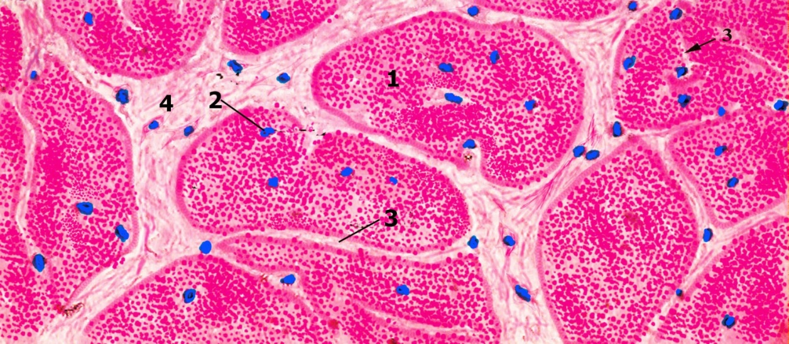

Fig. 5.16

The most common amino acids of collagen are glycine, proline, hydroxyproline, and hydroxylysine. The six major collagen types are:
- Type I: in connective tissue proper, bone, dentin, and cementum
- Type II: in hyaline and elastic cartilages
- Type III: reticular fibers
- Type IV: lamina densa of the basal lamina
- Type V: in the placenta; associated with type I collagen
- Type VII: attaching the basal lamina to the lamina reticularis
Most of the fiber types display a 67-nm periodicity in electron micrographs, which is due to the deposition of heavy metals in the gap regions of the fiber (Fig. 5.10). Type IV collagen is not assembled into fibers and thus does not possess a periodicity. Elastic fibers (Fig. 5.9) are composed of elastin and microfibrils. These fibers are highly elastic and may be stretched to 150% of their resting length without breaking. Their elasticity is due to the protein elastin, and their stability is due to the presence of microfibrils. Elastin is an amorphous material whose main amino acid components are glycine and proline. Additionally, elastin is rich in lysine, the amino acid responsible for the formation of the highly deformable desmosine residues that impart a high degree of elasticity to these fibers. Dense Connective Tissue Dense connective tissue contains a greater abundance of fibers and fewer cells than loose connective tissue. Dense connective tissue (Fig. 5.16) contains most of the same components found in loose connective tissue, except that it has many more fibers and fewer cells. The orientation and the arrangements of the bundles of collagen fibers in this tissue make it resistant to stress. When the collagen fiber bundles are arranged randomly, the tissue is called dense irregular connective tissue. When fiber bundles of the tissue are arranged in parallel or organized fashion, the tissue is called dense regular connective tissue, which is divided into collagenous and elastic types. Dense irregular connective tissue contains mostly coarse collagen fibers interwoven into a meshwork that resists stress from all directions . The collagen bundles are packed so tightly that space is limited for ground substance and cells. Fine networks of elastic fibers are often scattered about the collagen bundles. Fibroblasts, the most abundant cells of this tissue, are located in the interstices between collagen bundles. Dense irregular connective tissue constitutes the dermis of skin, the sheaths of nerves, and the capsules of the spleen, testes, ovary, kidney, and lymph nodes.

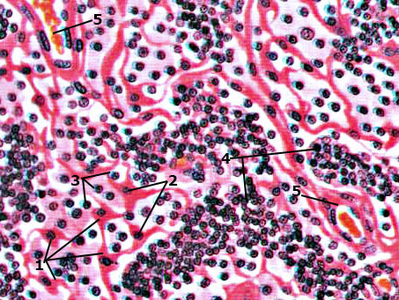

Fig. 5.17

Dense regular collagenous connective tissue is composed of coarse collagen bundles densely packed and oriented into parallel cylinders or sheets that resist tensile forces . Because of the tight packing of the collagen fibers, little space can be occupied by ground substance and cells. Thin, sheet-like fibroblasts are located between bundles of collagen with their long axes parallel to the bundles. Tendons, ligaments, and aponeuroses are examples of dense regular collagenous connective tissue. Dense regular elastic connective tissue possesses coarse branching elastic fibers with only a few collagen fibers forming networks. Scattered throughout the interstitial spaces are fibroblasts. The elastic fibers are arranged parallel to one another and form either thin sheets or fenestrated membranes. The latter are present in large blood vessels, ligamenta flava of the vertebral column, and the suspensory ligament of the penis. Reticular Tissue. Type III collagen is the major fiber component of reticular tissue (Fig. 5.17). The collagen fibers form mesh-like networks interspersed with fibroblasts and macrophages . It is the fibroblasts that synthesize the type III collagen. Reticular tissue forms the architectural framework of liver sinusoids, adipose tissue, bone marrow, lymph nodes, spleen, smooth muscle, and the islets of Langerhans. Cartilage and bone are both specialized connective tissues. Cartilage possesses a firm pliable matrix that resists mechanical stresses. Bone matrix is one of the hardest tissues of the body, and it too resists stresses placed upon it. Both of these connective tissues have cells that are specialized to secrete the matrix in which, subsequently, the cells become trapped. Although cartilage and bone have many varied functions, some of the functions are similar and related. Both are involved in supporting the body because they are intimately associated in the skeletal system. Most of the long bones of the body are formed first in the embryo as cartilage, which then acts as a template that is later replaced by bone; this process is referred to as endochondral bone formation. Most of the flat bones are formed within preexisting membranous sheaths; thus this method of osteogenesis is known as intramembranous bone formation.

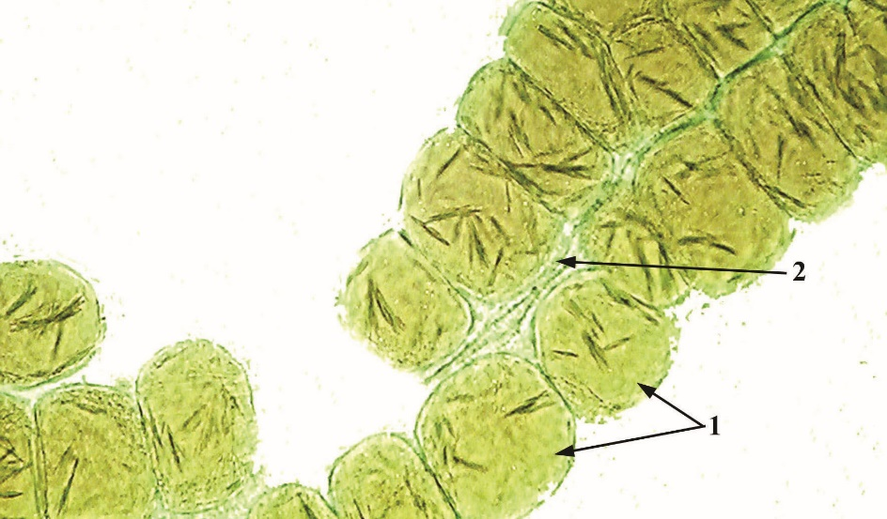

Şək. 5.18

Cartilage and bone are both specialized connective tissues. Cartilage possesses a firm pliable matrix that resists mechanical stresses. Bone matrix is one of the hardest tissues of the body, and it too resists stresses placed upon it. Both of these connective tissues have cells that are specialized to secrete the matrix in which, subsequently, the cells become trapped. Although cartilage and bone have many varied functions, some of the functions are similar and related. Both are involved in supporting the body because they are intimately associated in the skeletal system. Most of the long bones of the body are formed first in the embryo as cartilage, which then acts as a template that is later replaced by bone; this process is referred to as endochondral bone formation. Most of the flat bones are formed within preexisting membranous sheaths; thus this method of osteogenesis is known as intramembranous bone formation. Cartilage possesses cells called chondrocytes, which occupy small cavities called lacunae within the extracellular matrix they secreted. The substance of cartilage is neither vascularized nor supplied with nerves or lymphatic vessels; however, the cells receive their nourishment from blood vessels of surrounding connective tissues by diffusion through the matrix. The extracellular matrix is composed of glycosaminoglycans and proteoglycans, which are intimately associated with the collagen and elastic fibers embedded within the matrix. The flexibility and resistance of cartilage to compression permit it to function as a shock absorber, and its smooth surface permits almost friction-free movement of the joints of the body as it covers the articulating surfaces of the bones. There are three types of cartilage according to the fibers present in the matrix :
- Hyaline cartilage contains type II collagen in its matrix; it is the most abundant cartilage in the body and serves many functions.
- Elastic cartilage contains type II collagen and abundant elastic fibers scattered throughout its matrix, giving it more pliability.
- Fibrocartilage possesses dense, coarse type I collagen fibers in its matrix, allowing it to withstand strong tensile forces.
The perichondrium is a connective tissue sheath covering that overlies most cartilage. It has an outer fibrous layer and inner cellular layer whose cells secrete cartilage matrix. The perichondrium is vascular, and its vessels supply nutrients to the cells of cartilage. In areas where the cartilage has no perichondrium (e.g., the articular surfaces of the bones forming a joint), the cartilage cells receive their nourishment from the synovial fluid that bathes the joint surfaces. Perichondria are present in elastic and most hyaline cartilages, but absent in fibrocartilage.
Hyaline Cartilage Hyaline cartilage, the most abundant cartilage in the body, forms the template for endochondral bone formation. Hyaline cartilage (Fig. 5.19), a bluish-gray, semitranslucent, pliable substance, is the most common cartilage of the body. It is located in the nose and larynx, on the ventral ends of the ribs where they articulate with the sternum, in the tracheal rings and bronchi, and on the articulating surfaces of the movable joints of the body. Also, it is this cartilage that forms the cartilage template of many of the bones during embryonic development and constitutes the epiphyseal plates of growing bones.

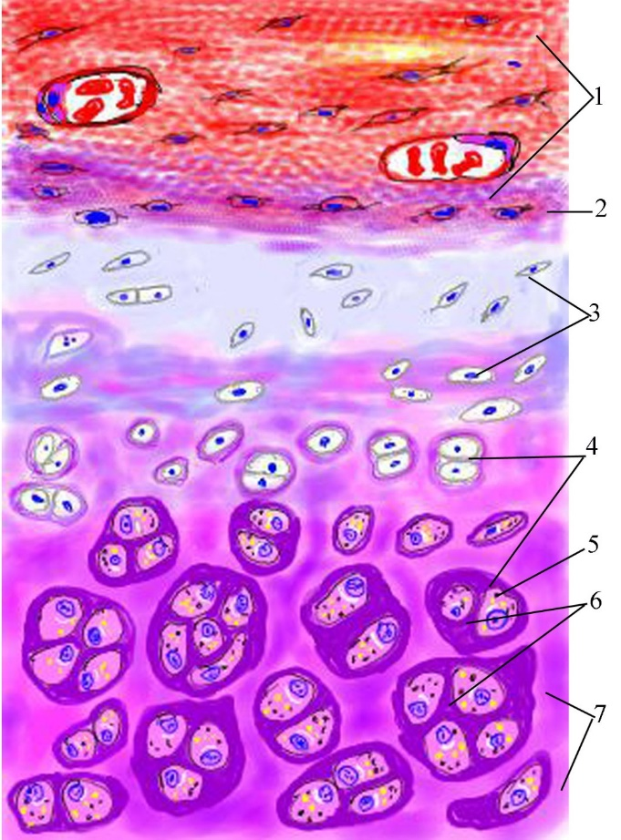

Fig. 5.19

Histogenesis and Growth of Hyaline Cartilage. Cells responsible for hyaline cartilage formation differentiate from mesenchymal cells. In the region where cartilage is to form, individual mesenchymal cells retract their processes, round up, and congregate in dense masses called chondrification centers. These cells differentiate into chondroblasts and commence secreting the typical cartilage matrix around themselves. As this process continues, the chondroblasts become entrapped in their own matrix in small individual compartments called lacunae. Chondroblasts that are surrounded by this matrix are referred to as chondrocytes . These cells are still capable of cell division, forming a cluster of two to four or more cells in a lacuna. These groups are known as isogenous groups and represent one, two, or more cell divisions from an original chondrocyte . As the cells of an isogenous group manufacture matrix, they are pushed away from each other, forming separate lacunae and thus enlarging the cartilage from within. This type of growth is called interstitial growth. Mesenchymal cells at the periphery of the developing cartilage differentiate to form fibroblasts. These cells manufacture a dense irregular collagenous connective tissue, the perichondrium, responsible for the growth and maintenance of the cartilage. The perichondrium has two layers, an outer fibrous layer composed of type I collagen, fibroblasts, and blood vessels and an inner cellular layer composed mostly of chondrogenic cells. The chondrogenic cells undergo division and differentiate into chondroblasts, which begin to elaborate matrix. In this way cartilage also grows by adding to its periphery, a process called appositional growth. Interstitial growth occurs only in the early phase of hyaline cartilage formation. Articular cartilage lacks a perichondrium and increases in size only by interstitial growth. This type of growth also occurs in the epiphyseal plates of long bones, where the lacunae are arranged in a longitudinal orientation parallel to the long axis of the bone; therefore, interstitial growth serves to lengthen the bone. The cartilage in the remainder of the body grows mostly by apposition, a controlled process that may continue during the life of the cartilage. It is interesting that mesenchymal cells located within the chondrification centers are induced to become secreting chondroblasts by their attachments and the chemistry of the surrounding extracellular matrix. Also, if chondroblasts are removed from their secreted cartilage matrix and are grown in a monolayer in a low-density substrate, they will cease to secrete "cartilage matrix" containing type II collagen. Instead they will become fibroblast-like and start secreting type I collagen. Cartilage Cells. Three types of cells are associated with cartilage: chondrogenic cells, chondroblasts, and chondrocytes. Chondrogenic cells are spindle-shaped, narrow cells that are derived from mesenchymal cells. They possess an ovoid nucleus with one or two nucleoli. Their cytoplasm is sparse, and electron micrographs of chondrogenic cells display a small Golgi apparatus, a few mitochondria, some profiles of rough endoplasmic reticulum (RER), and an abundance of free ribosomes. These cells can differentiate into both chondroblasts and osteoprogenitor cells. Chondroblasts are derived from two sources: mesenchymal cells located within the center of chondrification and chondrogenic cells of the inner cellular layer of the perichondrium (as in appositional growth). Chondroblasts are plump, basophilic cells that display the organelles required for protein synthesis. Electron micrographs of these cells demonstrate a rich network of RER, a well-developed Golgi complex, numerous mitochondria, and an abundance of secretory vesicles. Chondrocytes are chondroblasts that are surrounded by matrix. Those near the periphery are ovoid, whereas those deeper in the cartilage are more rounded, with a diameter of 10 to 30 μm. Histological processing creates artifactual shrinkage and distortion of the cells. Chondrocytes display a large nucleus with a prominent nucleolus and the usual organelles of protein-secreting cells. Young chondrocytes have a pale-staining cytoplasm with many mitochondria, an elaborate RER, a well-developed Golgi apparatus, and glycogen. Older chondrocytes, which are relatively quiescent, display a greatly reduced complement of organelles, with an abundance of free ribosomes. Thus, these cells can resume active protein synthesis if they revert to chondroblasts. Matrix of Hyaline Cartilage. The matrix of hyaline cartilage is composed of type II collagen, proteoglycans, glycoproteins, and extracellular fluid. The semitranslucent blue-gray matrix of hyaline cartilage contains up to 40% of its dry weight in collagen. In addition, it contains proteoglycans, glycoproteins, and extracellular fluid. Because the refractive index of the collagen fibrils and that of the ground substance are nearly the same, the matrix appears to be an amorphous, homogeneous mass with the light microscope. The matrix of hyaline cartilage contains primarily type II collagen, but types IX, X, and XI and other minor collagens are also present in small quantities. Type II collagen does not form large bundles, although the bundle thickness increases with distance from the lacunae. Fiber orientation appears to be related to the stresses placed on the cartilage. For example, in articular cartilage, the fibers near the surface are oriented parallel to the surface, whereas deeper fibers seem to be oriented in curved columns. The matrix is subdivided into two regions: the territorial matrix, around each lacuna, and the interterritorial matrix . The territorial matrix, a 50-μm-wide band, is poor in collagen and rich in chondroitin sulfate, which contributes to its basophilic and intense staining with periodic acid-Schiff (PAS) reagent. The bulk of the matrix is interterritorial matrix, which is richer in type II collagen and poorer in proteoglycans than the territorial matrix. A small region of the matrix, 1- to 3-mm thick, immediately surrounding the lacuna is known as the pericellular capsule. It displays a fine meshwork of collagen fibers embedded in a basal lamina-like substance. These fibers may represent some of the other minor collagens present in hyaline cartilage; it has been suggested that the pericellular capsule may protect chondrocytes from mechanical stresses. Cartilage matrix is rich in aggrecans, large proteoglycan molecules composed of protein cores to which glycosaminoglycan molecules (chondroitin 4-sulfate, chondroitin 6-sulfate, and heparan sulfate) are covalently linked. As many as 100 to 200 aggrecan molecules are linked noncovalently to hyaluronic acid, forming huge aggrecan composites that can be 3- to 4-μm long. The abundant negative charges associated with these exceedingly large proteoglycan molecules attract cations, predominantly Na⁺ ions, which in turn attract water molecules. In this way, the cartilage matrix becomes hydrated to such an extent that up to 80% of the wet weight of cartilage is water, accounting for the ability of cartilage to resist forces of compression. Not only do hydrated proteoglycans fill the interstices among the collagen fiber bundles, but their glycosaminoglycan side chains form electrostatic bonds with the collagen. Thus, the ground substance and fibers of the matrix form a cross-linked molecular framework that resists tensile forces. Cartilage matrix also contains the adhesive glycoprotein chondronectin. This large molecule, similar to fibronectin, has binding sites for type II collagen, chondroitin 4-sulfate, chondroitin 6-sulfate, hyaluronic acid, and integrins (transmembrane proteins) of chondroblasts and chondrocytes. Chondronectin thus assists these cells in maintaining their contact with the fibrous and amorphous components of the matrix. Histophysiology of Hyaline Cartilage. The smoothness of hyaline cartilage and its ability to resist forces of both compression and tension are essential to its function at the articular surfaces of joints. Because cartilage is avascular, nutrients and oxygen must diffuse through the water of hydration present in the matrix. The inefficiency of such a system necessitates a limit on the width of cartilage. There is a constant turnover in the proteoglycans of cartilage that changes with age. Hormones and vitamins also exert influence on the growth, development, and function of cartilage. Many of these substances also affect skeletal formation and growth.

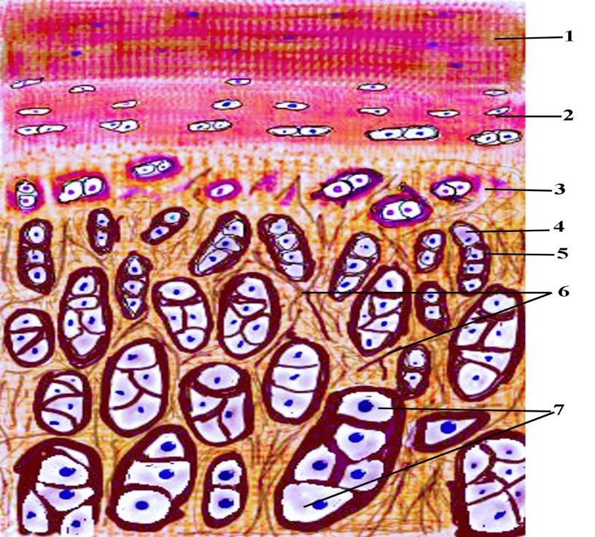

Fig. 5.20

Elastic cartilage greatly resembles hyaline cartilage, except that its matrix and perichondrium possess elastic fibers. Elastic cartilage (Fig. 5.20) is located in the pinna of the ear, the external and internal auditory tubes, the epiglottis, and the larynx (cuneiform cartilage). Because of the presence of elastic fibers, elastic cartilage is somewhat yellow and is more opaque than hyaline cartilage in the fresh state. In most respects, elastic cartilage is identical to hyaline cartilage and is often associated with it. The outer fibrous layer of the perichondrium is rich in elastic fibers. The matrix of elastic cartilage possesses abundant, fine to coarse branching elastic fibers interposed with type II collagen fiber bundles, giving it much more flexibility than the matrix of hyaline cartilage. The chondrocytes of elastic cartilage are more abundant and larger than those of hyaline cartilage. The matrix is not as ample as in hyaline cartilage, and the elastic fiber bundles of the territorial matrix are larger and coarser than those of the interterritorial matrix.

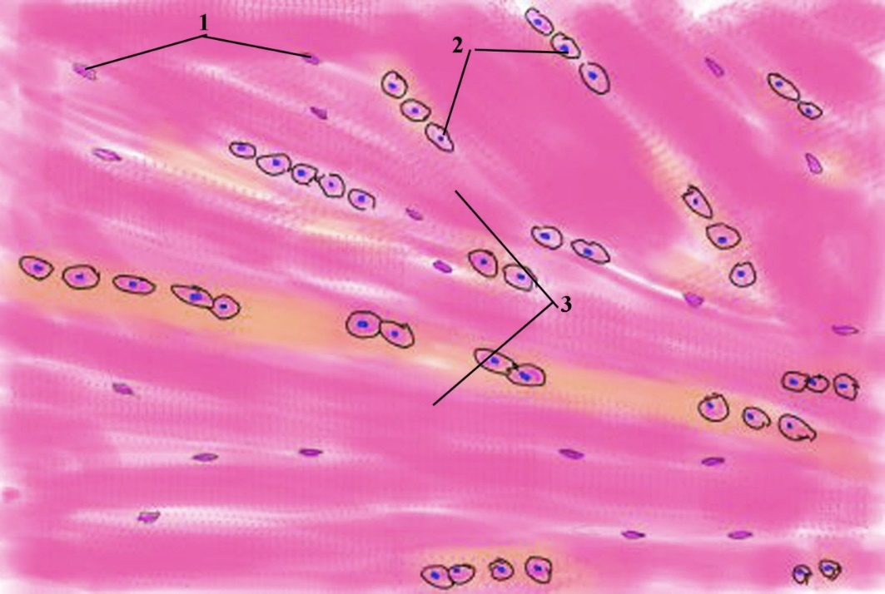

Fig. 5.21

Fibrocartilage (Fig. 5.21), unlike hyaline and elastic cartilage, does not possess a perichondrium and its matrix includes type I collagen. Fibrocartilage is present in intervertebral disks, in the pubic symphysis, in articular disks, and attached to bone. It is associated with hyaline cartilage and with dense connective tissue, which it resembles. Unlike the other two types of cartilage, fibrocartilage does not possess a perichondrium. It displays a scant amount of matrix (rich in chondroitin sulfate and dermatan sulfate), and exhibits bundles of type I collagen, which stain acidophilic. Chondrocytes are often aligned in alternating parallel rows with the thick, coarse bundles of collagen, which parallel the tensile forces attendant on this tissue. Chondrocytes of fibrocartilage usually arise from fibroblasts that begin to manufacture proteoglycans. As the ground substance surrounds the fibroblast, the cell becomes incarcerated in its own matrix and differentiates into a chondrocyte. Intervertebral disks represent an example of the organization of fibrocartilage. They are interposed between the hyaline cartilage coverings of the articular surface of successive vertebrae. Each disk contains a gelatinous center, called the nucleus pulposus, which is composed of cells, derived from the notochord, lying within a hyaluronic acid-rich matrix. These cells disappear by the 20th year of life. Much of the nucleus pulposus is surrounded by the annulus fibrosus, layers of fibrocartilage whose type I collagen fibers run vertically between the hyaline cartilages of the two vertebrae. The fibers of adjacent lamellae are oriented obliquely to each other, providing support to the gelatinous nucleus pulposus. The annulus fibrosus provides resistance against tensile forces, whereas the nucleus pulposus resists forces of compression. BONE. Bone is a specialized connective tissue whose extracellular matrix is calcified, incarcerating the cells that secreted it. Although bone is one of the hardest substances of the body, it is a dynamic tissue that constantly changes shape in relation to the stresses placed on it. For example, pressures applied to bone lead to its resorption, whereas tension applied to it results in development of new bone. In applying these facts, the orthodontist is able to remodel the bone of the dental arches by moving and straightening the teeth to correct malocclusion, thus providing the patient with a more natural and pleasant smile. Bone is the primary structural framework for support and protection of the organs of the body, including the brain and spinal cord and the structures within the thoracic cavity, namely the lungs and heart. The bones also serve as levers for the muscles attached to them, thereby multiplying the force of the muscles to attain movement. Bone is a reservoir for several minerals of the body; for example, it stores about 99% of the body's calcium. Bone contains a central cavity, the marrow cavity, which houses the bone marrow, a hemopoietic organ. Bone is covered on its external surface, except at synovial articulations, with periosteum, which consists of an outer layer of dense fibrous connective tissue and an inner cellular layer containing osteoprogenitor (osteogenic) cells. The central cavity of a bone is lined with endosteum, a specialized thin, connective tissue composed of a monolayer of osteoprogenitor cells and osteoblasts. Bone is composed of cells lying in an extracellular matrix that has become calcified. The calcified matrix is composed of fibers and ground substance. The fibers constituting bone are primarily type I collagen. The ground substance is rich in proteoglycans with chondroitin sulfate and keratan sulfate side chains. In addition, glycoproteins such as osteonectin, osteocalcin, osteopontin, and bone sialoprotein are present. The cells of bone include osteoprogenitor cells, which differentiate into osteoblasts. Osteoblasts are responsible for secreting the matrix. When these cells are surrounded by matrix, they become quiescent and are known as osteocytes. The spaces osteocytes occupy are known as lacunae. Osteoclasts, multinucleated giant cells derived from fused bone marrow precursors, are responsible for bone resorption and remodeling. Because bone is such a hard tissue, two methods are employed to prepare it for study. Decalcified sections can be prepared by decalcifying the bone in an acid solution to remove the calcium salts. The tissue can then be embedded, sectioned, and routinely stained for study. Ground sections are prepared by sawing the bone into thin slices, followed by grinding the sections with abrasives between glass plates. When the section is sufficiently thin for study with light microscope, it is mounted for study. Bone matrix has inorganic and organic constituents. Inorganic Component. The inorganic constituents of bone are crystals of calcium hydroxyapatite, composed mostly of calcium and phosphorus. The inorganic portion of bone, which constitutes about 65% of its dry weight, is composed mainly of calcium and phosphorus along with other components, including bicarbonate, citrate, magnesium, sodium, and potassium. Calcium and phosphorus exist primarily in the form of hydroxyapatite crystals [Ca₁₀(PO₄)₆(OH)₂], but calcium phosphate is also present in an amorphous form. Hydroxyapatite crystals (40-nm long by 25-nm wide by 1.5- to 3-nm thick) are arranged in an ordered fashion along the type I collagen fibers; they are deposited into the gap regions of the collagen but also are present along the overlap region. The free surface of the crystals is surrounded by amorphous ground substance. The surface ions of the crystals attract H₂O and form a hydration shell, which permits ion exchange with the extracellular fluid. Bone is one of the hardest and strongest substances in the body. Its hardness and strength are due to the association of hydroxyapatite crystals with collagen. If bone is decalcified (i.e., all of the mineral is removed from the bone), it still retains its original shape but becomes so flexible that it can be bent like a piece of tough rubber. If the organic component is extracted from bone, the mineralized skeleton still retains its original shape, but it becomes extremely brittle and can be fractured with ease. Organic Component The predominant organic component of bone is type I collagen. The organic component of bone matrix, constituting approximately 35% of the dry weight of bone, includes fibers that are almost exclusively type I collagen. Collagen, most of which is type I, makes up about 80% to 90% of the organic component of bone. It is formed in large (50 to 70 nm in diameter) bundles displaying a typical 67-nm periodicity. Type I collagen in bone is highly cross-linked, which prevents it from being easily extracted. The fact that bone matrix stains with PAS reagent and displays slight metachromasia indicates the presence of sulfated glycosaminoglycans, namely chondroitin sulfate and keratan sulfate. These form small proteoglycan molecules with short protein cores to which the glycosaminoglycans are covalently bound. The proteoglycans are noncovalently bound, via link proteins, to hyaluronic acid, forming very large aggrecan composites. The abundance of collagen, however, causes the matrix to be acidophilic. Several glycoproteins are also present in the bone matrix. These appear to be restricted to bone and include osteocalcin, which binds to hydroxyapatite, and osteopontin, which also binds to hydroxyapatite but has additional binding sites for other components as well as for integrins present on osteoblasts and osteoclasts. Vitamin D stimulates the synthesis of these glycoproteins. Bone sialoprotein, another matrix protein, has binding sites for matrix components and integrins of osteoblasts and osteocytes, suggesting its involvement in the adherence of these cells to bone matrix.
Cells of Bone: The cells of bone are osteoprogenitor cells, osteoblasts, osteocytes, and osteoclasts. Osteoprogenitor Cells Osteoprogenitor cells are derived from embryonic mesenchymal cells and retain their ability to undergo mitosis. Osteoprogenitor cells are located in the inner cellular layer of the periosteum, lining haversian canals, and in the endosteum. These cells, derived from embryonic mesenchyme, remain in place throughout postnatal life and can undergo mitotic division and have the potential to differentiate into osteoblasts. Moreover, under certain conditions of low oxygen tension, these cells may differentiate into chondrogenic cells. Osteoprogenitor cells are spindle-shaped and have a pale-staining oval nucleus; their scant pale-staining cytoplasm displays sparse RER and a poorly developed Golgi apparatus but an abundance of free ribosomes. These cells are most active during the period of intense bone growth. Osteoblasts. Osteoblasts not only synthesize the organic matrix of bone but also possess receptors for parathyroid hormone. Osteoblasts are derived from osteoprogenitor cells and develop under the influence of the bone morphogenic protein (BMP) family and transforming growth factor-β.Osteoblasts are responsible for the synthesis of the organic protein components of the bone matrix, including type I collagen, proteoglycans, and glycoproteins. Additionally, they produce RANKL (receptor for activation of nuclear factor kappa B), osteocalcin (for bone mineralization), osteopontin (for formation of sealing zone between osteoclasts and the subosteoclastic compartment), osteonectin (related to bone mineralization), bone sialoprotein (binding osteoblasts to extracellular matrix), and macrophage colony-stimulating factor (M-CSF) (discussed later). Osteoblasts are located on the surface of the bone in a sheet-like arrangement of cuboidal to columnar cells.When actively secreting matrix, they exhibit a basophilic cytoplasm. The organelles of osteoblasts are polarized so that the nucleus is located away from the region of secretory activity, which houses secretory granules believed to contain matrix precursors. The contents of these vesicles stain pink with PAS reagent. Electron micrographs exhibit abundant RER, a well-developed Golgi complex (Fig. 7-7A), and numerous secretory vesicles containing flocculent material that accounts for the PAS pink-staining vacuoles observed in the light microscope. Osteoblasts extend short processes that make contact with those of neighboring osteoblasts, as well as long processes that make contact with processes of osteocytes. Although these processes form gap junctions with one another, the number of gap junctions between osteoblasts is much fewer than those between osteocytes. As osteoblasts exocytose their secretory products, each cell surrounds itself with the bone matrix it has just produced; when this occurs, the incarcerated cell is referred to as an osteocyte, and the space it occupies is known as a lacuna. Most of the bone matrix becomes calcified; however, osteoblasts as well as osteocytes are always separated from the calcified substance by a thin, noncalcified layer known as the osteoid (uncalcified bone matrix). Surface osteoblasts that cease to form matrix revert to a more flattened-shaped quiescent state and are called bone-lining cells. Although these cells appear to be similar to osteoprogenitor cells, they are most likely incapable of dividing but can be reactivated to the secreting form with the proper stimulus. Osteoblasts have several factors on their cell membranes, the most significant of which are integrins and parathyroid hormone receptors. When parathyroid hormone binds to these receptors, it stimulates osteoblasts to secrete osteoprotegerin ligand (OPGL), a factor that induces the differentiation of preosteoclasts into osteoclasts and it increases RANKL expression. Also osteoblasts secrete an osteoclast-stimulating factor, which activates osteoclasts to resorb bone. Osteoblasts also secrete enzymes responsible for removing osteoid so that osteoclasts can make contact with the mineralized bone surface. Osteocytes. Osteocytes are mature bone cells derived from osteoblasts that became trapped in their lacunae. Osteocytes (Fig. 5.22) are mature bone cells, derived from osteoblasts, that are housed in lacunae within the calcified bony matrix. There are as many as 20,000 to 30,000 osteocytes per mm³ of bone. Radiating out in all directions from the lacunaa are narrow, tunnel-like spaces (canaliculi) that house cytoplasmic processes of the osteocyte. These processes make contact with similar processes of neighboring osteocytes, forming gap junctions through which ions and small molecules can move between the cells. The canaliculi also contain extracellular fluid carrying nutrients and metabolites that nourish the osteocytes. Osteocytes conform to the shape of their lacunae. Their nucleus is flattened, and their cytoplasm is poor in organelles, displaying scant RER and a greatly reduced Golgi apparatus. Although osteocytes appear to be inactive cells, they secrete substances necessary for bone maintenance. These cells have also been implicated in mechanotransduction, in that they respond to stimuli that place tension on bone by releasing cyclic adenosine monophosphate (cAMP), osteocalcin, and insulin-like growth factor. The release of these factors facilitates the recruitment of preosteoblasts to assist in the remodeling of the skeleton (adding more bone) not only during growth and development but also during the long-term redistribution of forces acting on the skeleton. An example of such remodeling is evident in the comparison of male and female skeletons, in which the muscle attachments of the male skeleton are usually better defined than those of the female skeleton.

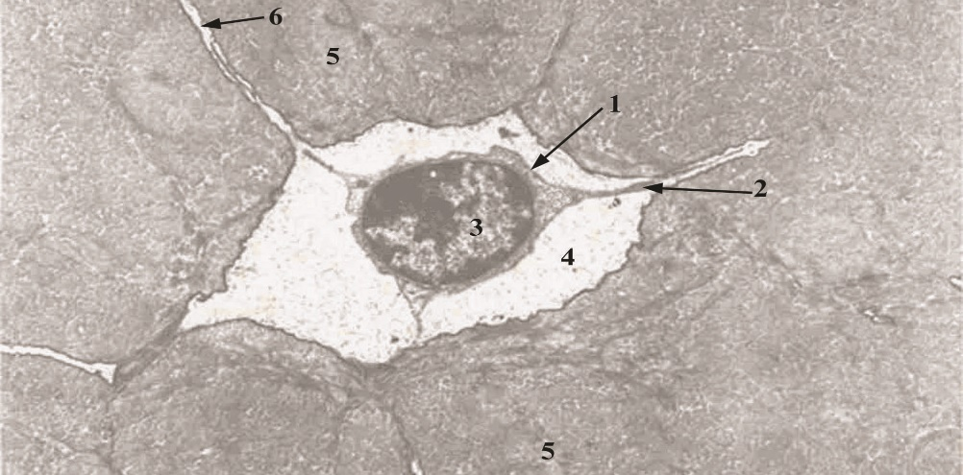

Fig. 5.22

The interval between the osteocyte plasmalemma and the walls of the lacunae and canaliculi, known as the periosteocytic space, is occupied by extracellular fluid. Considering the extensive network of the canaliculi and the sheer number of osteocytes present in the skeleton of an average person, the volume of the periosteocytic space and the surface area of the walls have been calculated to be a staggering 1.3 L and as much as 5000 m², respectively. It has been suggested that the 1.3 L of extracellular fluid occupying the periosteocytic space is exposed to as much as 20 g of exchangeable calcium that can be resorbed from the walls of these spaces. The resorbed calcium gains access to the bloodstream and ensures the maintenance of adequate blood calcium levels. Osteoclasts. Osteoclasts are multinucleated cells originating from granulocyte-macrophage progenitors. They play a role in bone resorption. The precursor of the osteoclast originates in the bone marrow. Osteoclasts have receptors for osteoclast-stimulating factor, colony-stimulating factor-1, osteoprotegerin (OPG), and calcitonin, among others. Osteoclasts are responsible for resorbing bone, and after they finish doing so, these cells probably undergo apoptosis. Morphology of Osteoclasts. Osteoclasts are large, motile, multinucleated cells 150 μm in diameter; they contain up to 50 nuclei and have an acidophilic cytoplasm. Osteoclasts were once thought to be derived from the fusion of many blood-derived monocytes, but the newest evidence shows that they have a bone marrow precursor in common with monocytes termed the mononuclear-phagocyte system. These precursor cells are stimulated by macrophage colony-stimulating factor to undergo mitosis. In the presence of bone, these osteoclast precursors fuse to produce the multinucleated osteoclasts. Osteoblasts secrete three signaling molecules that regulate the differentiation of osteoclasts. The first of these signals, the macrophage colony-stimulating factor (M-CSF) binds to a receptor on the macrophage, inducing it to become a proliferating osteoclast precursor, and it induces the expression of the receptor for activation of nuclear factor kappa B (RANK) on the precursor. Another osteoblast signaling molecule, RANKL, binds to the RANKL receptor on the osteoclastic precursor, inducing it to differentiate into the multinucleated osteoclast, activating it, and enhancing bone resorption. The third signaling molecule, OPG, a member of the tumor necrosis factor receptor (TNFR) family, can serve as a decoy by interacting with RANKL, thus prohibiting it from binding to the macrophage and thus inhibiting osteoclast formation. In this way, RANKL, RANK, and OPG regulate bone metabolism and osteoclastic activity. OPG is produced not only by osteoblasts but by cells of many other tissues, including the cardiovascular system, lung, kidney, intestines, as well as hematopoietic and immune cells. Therefore it is not surprising that its expression is modulated by various means by cytokines, peptides, hormones, drugs, and so forth. In bone, OPG not only inhibits the differentiation of precursor cells into osteoclasts but also suppresses the osteoclast's bone resorptive capacities. Also, tensional forces on bone trigger OPG and mRNA synthesis. Osteoclasts occupy shallow depressions, called Howship's lacunae, that identify regions of bone resorption. An osteoclast active in bone resorption may be subdivided into four morphologically recognizable regions:
- 1 The basal zone, located farthest from the Howship lacunae, houses most of the organelles, including the multiple nuclei and their associated Golgi complexes and centrioles. Mitochondria, RER, and polysomes are distributed throughout the cell but are more numerous near the ruffled border.
- 2 The ruffled border is the portion of the cell that is directly involved in resorption of bone. Its finger-like processes are active and dynamic, changing their configuration continuously as they project into the resorption compartment, known as the subosteoclastic compartment. The cytoplasmic aspect of the ruffled border plasmalemma displays a regularly spaced, bristle-like coat that increases the thickness of the plasma membrane of this region.
- 3 The clear zone is the region of the cell that immediately surrounds the periphery of the ruffled border. It is organelle-free but contains many actin microfilaments that form an actin ring and appear to function in helping integrins of the clear zone plasmalemma maintain contact with the bony periphery of the Howship lacunae. In fact, the plasma membrane of this region is so closely applied to the bone that it forms the sealing zone of the subosteoclastic compartment. Thus, the clear zone isolates the subosteoclastic compartment from the surrounding region, establishing a microenvironment whose contents may be modulated by cellular activities. For the osteoclast to be able to resorb bone, the actin ring must first be formed, and its formation may be facilitated by OPGL. Then the ruffled border is formed, whose finger-like processes increase the surface area of the plasmalemma in the region of bone resorption, facilitating the resorptive process.
- 4 The vesicular zone of the osteoclast consists of numerous endocytotic and exocytotic vesicles that ferry lysosomal enzymes and metalloproteinases into the subosteoclastic compartment and the products of bone degradation into the cell . The vesicular zone is between the basal zone and the ruffled border.

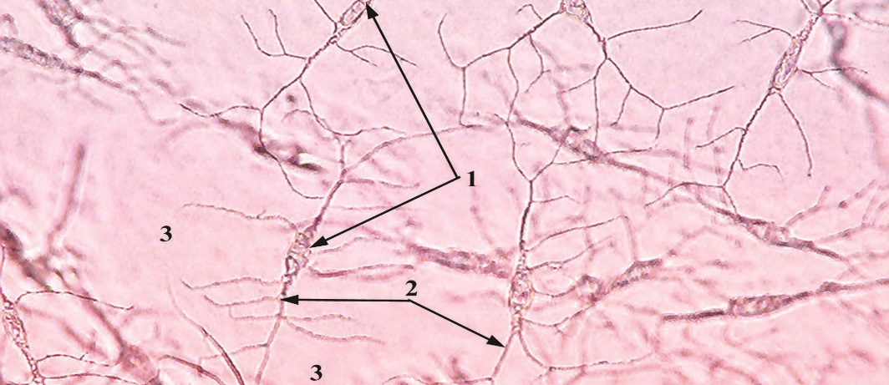

Fig. 5.23

Mechanism of Bone Resorption. Within osteoclasts, the enzyme carbonic anhydrase catalyzes the intracellular formation of carbonic acid (H₂CO₃) from carbon dioxide and water. Carbonic acid dissociates within the cells into H⁺ ions and bicarbonate ions, HCO₃⁻. The bicarbonate ions, accompanied by Na⁺ ions, cross the plasmalemma and enter nearby capillaries. Proton pumps in the plasmalemma of the ruffled border of the osteoclasts actively transport H⁺ ions into the subosteoclastic compartment, reducing the pH of the microenvironment (Cl⁻ ions follow passively). The inorganic component of the matrix is dissolved as the environment becomes acidic; the liberated minerals enter the osteoclast cytoplasm to be delivered to nearby capillaries. Lysosomal hydrolases and metalloproteinases, such as collagenase and gelatinase, are secreted by osteoclasts into the subosteoclastic compartment to degrade the organic components of the decalcified bone matrix. The degradation products are endocytosed by the osteoclasts and further broken down into amino acids, monosaccharides, and disaccharides, which then are released into nearby capillaries.
Bones are classified according to their shape:
- Long bones display a shaft located between two heads (e.g., tibia).
- Short bones have more or less the same width and length (e.g., carpal bones of the wrist).
- Flat bones are flat, thin, and plate-like (e.g., bones forming the brain case of the skull).
- Irregular bones have an irregular shape that does not fit into the other classes (e.g., sphenoid and ethmoid bones within the skull).
- Sesamoid bones develop within tendons, where they increase the mechanical advantage for the muscle (e.g., patella) across a joint.
Gross observations of the femur (a long bone) cut in longitudinal section reveal two different types of bone structure. The very dense bone on the outside surface is compact bone, whereas the porous portion lining the marrow cavity is cancellous or spongy bone. Closer observation of the spongy bone reveals branching bony trabeculae and spicules jutting out from the internal surface of the compact bone into the marrow cavity. There are no haversian systems in spongy bone, but there are irregular arrangements of lamellae. These contain lacunae housing osteocytes that are nourished by diffusion from the marrow cavity, which is filled with bone marrow. The shaft of a long bone is called the diaphysis, and the articular ends are called the epiphyses (singular, epiphysis). In a person who is still growing, the diaphysis is separated from each epiphysis by the epiphyseal plate of cartilage. The articular end of the bone is enlarged and sculpted to articulate with its bony counterpart of the joint. The surface of the articulating end is covered with only a thin layer of compact bone overlying spongy bone. On top of this is the highly polished articular hyaline cartilage, which reduces friction as it moves against the articular cartilage of the bony counterpart of the joint. The area of transition between the epiphyseal plate and the diaphysis is called the metaphysis, where columns of spongy bone are located. It is from the epiphyseal plate and the metaphysis that bone grows in length. The diaphysis is covered by a periosteum except where tendons and muscles insert into the bone. There is no periosteum on the surfaces of bone covered by articular cartilage. Periosteum is also absent from sesamoid bones (e.g., patella), which are formed within tendons and function to increase the mechanical advantage across a joint. The periosteum is a noncalcified, dense, irregular, collagenous connective tissue covering the bone on its external surface and inserting into it via Sharpey's fibers. Periosteum is composed of two layers. The outer fibrous layer helps distribute vascular and nerve supply to bone, whereas the inner cellular layer possesses osteoprogenitor cells and osteoblasts. The flat bones of the skull develop by a method different from that of most of the long bones of the body. The inner and outer surfaces of the calvaria (skull cap) possess two relatively thick layers of compact bone called the inner and outer tables, which surround the spongy bone (diploë) sandwiched between them. The outer table possesses a periosteum, identified as the pericranium, whereas internally the inner table is lined with dura mater, which serves as a periosteum for the inner table and as a protective covering for the brain. Microscopically, bone is classified as either primary (immature) or secondary (mature) bone. Microscopic observations reveal two types of bone: primary bone, or immature or woven bone, and secondary bones, or mature or lamellar bone. Primary bone is immature (Fig. 5. 23) in that it is the first bone to form during fetal development and during bone repair. It has abundant osteocytes and irregular bundles of collagen, which are later replaced and organized as secondary bone except in certain areas (e.g., at sutures of the calvaria, insertion sites of tendons, and bony alveoli surrounding the teeth). The mineral content of primary bone is also much less than that of secondary bone. Secondary bone is mature bone composed of parallel or concentric bony lamellae (Fig. 5. 24) 3- to 7-μm thick. Osteocytes in their lacunae are dispersed at regular intervals between, or occasionally within, lamellae. Canaliculi, housing osteocytic processes, connect neighboring lacunae with one another, forming a network of intercommunicating channels that facilitate the flow of nutrients, hormones, ions, and waste products to and from osteocytes. In addition, osteocytic processes within these canaliculi make contact with similar processes of neighboring osteocytes and form gap junctions, permitting these cells to communicate with each other. Because the matrix of secondary bone is more calcified, it is stronger than primary bone. In addition, the collagen fibers of secondary bone are arranged so that they parallel each other within a given lamella. There are four lamellar systems in compact bone: outer circumferential lamellae, inner circumferential lamellae, osteons, and interstitial lamellae.

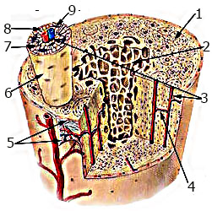

Fig. 5.24

Compact bone is composed of wafer-like thin layers of bone, lamellae, that are arranged in lamellar systems that are especially evident in the diaphyses of long bones. These lamellar systems are the outer circumferential lamellae, inner circumferential lamellae, osteons (haversian canal systems), and interstitial lamellae. The outer circumferential lamellae are just deep to the periosteum, forming the outermost region of the diaphysis, and contain Sharpey's fibers anchoring the periosteum to the bone. The inner circumferential lamellae, analogous to but not as extensive as outer circumferential lamellae, completely encircle the marrow cavity. Trabeculae of spongy bone extend from the inner circumferential lamellae into the marrow cavity, interrupting the endosteal lining of the inner circumferential lamellae. The bulk of compact bone is composed of an abundance of haversian canal systems (osteons); each system is composed of cylinders of lamellae, concentrically arranged around a vascular space known as the haversian canal (Fig. 5. 24). Frequently, osteons bifurcate along their considerable length. Each osteon is bounded by a thin cementing line, composed mostly of calcified ground substance with a scant amount of collagen fibers. Collagen fiber bundles are parallel to each other within a lamella but are oriented almost perpendicular to those of adjacent lamellae. This arrangement is possible because the collagen fibers follow a helical arrangement around the haversian canal within each lamella but are pitched differently in adjacent lamellae. Each haversian canal, lined by a layer of osteoblasts and osteoprogenitor cells, houses a neurovascular bundle with its associated connective tissue. Haversian canals of adjacent osteons are connected to each other by Volkmann's canals. These vascular spaces are oriented oblique to or perpendicular to haversian canals. The diameter of haversian canals varies from approximately 20 μm to about 100 μm. During the formation of osteons, the lamella closest to the cementing line is the first one to be formed. As additional lamellae are added to the system, the diameter of the haversian canal is reduced, and the thickness of the osteon wall increases. Because nutrients from blood vessels of the haversian canal must traverse canaliculi to reach osteocytes, an inefficient process, most osteons possess only 4 to 20 lamellae. As bone is being remodeled, osteoclasts resorb osteons and osteoblasts replace them. Remnants of osteons remain as irregular arcs of lamellar fragments, known as interstitial lamellae, surrounded by osteons. Like osteons, interstitial lamellae are also surrounded by cementing lines. Histogenesis of Bone. Bone formation during embryonic development may be of two types: intramembranous and endochondral. Bone that is formed by either of the two methods is identical histologically. The first bone formed is primary bone, which is later resorbed and replaced by secondary bone. Secondary bone continues to be resorbed throughout life, although at a slower rate. Intramembranous Bone Formation. Intramembranous bone formation occurs within mesenchymal tissue. Most flat bones are formed by intramembranous bone formation (Fig. 5.25). This process occurs in a richly vascularized mesenchymal tissue, whose cells make contact with each other via long processes. Mesenchymal cells differentiate into osteoblasts that secrete bone matrix, forming a network of spicules and trabeculae whose surfaces are populated by these cells. This region of initial osteogenesis is known as the primary ossification center. The collagen fibers of these developing spicules and trabeculae are randomly oriented, as expected in primary bone. Calcification quickly follows osteoid formation, and osteoblasts trapped in their matrices become osteocytes. The processes of these osteocytes are also surrounded by forming bone, establishing a system of canaliculi. Continuous mitotic activity of mesenchymal cells provides a supply of undifferentiated osteoprogenitor cells, which form osteoblasts. As the sponge-like network of trabeculae is established, the vascular connective tissue in their interstices is transformed into bone marrow. The addition of trabeculae to the periphery increases the size of the forming bone. Larger bones, such as the occipital bone of the base of the skull, have several ossification centers, which fuse with each other to form a single bone. The fontanelles ("soft spots") on the frontal and parietal bones of a newborn infant represent ossification centers that are not fused prenatally.

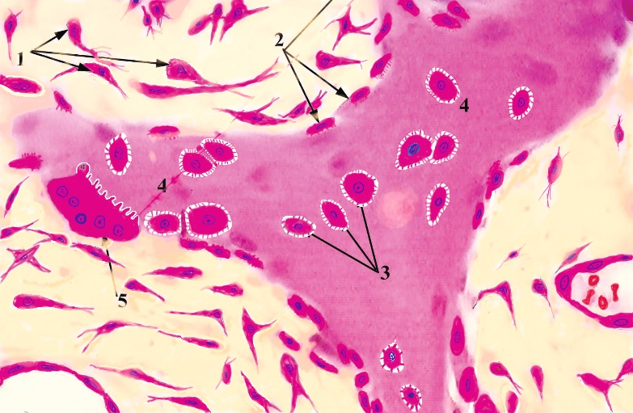

Fig. 5.25

- Regions of the mesenchymal tissues that remain uncalcified differentiate into the periosteum and endosteum of developing bone. Moreover, the spongy bone deep to the periosteum and the periosteal layer of the dura mater of flat bones are transformed into compact bone, forming the inner and outer tables with the intervening diploë. Endochondral Bone Formation. Endochondral bone formation requires the presence of a cartilage template. Most of the long and short bones of the body develop by endochondral bone formation (Fig. 5.26). This type of bone formation occurs in several phases, the most critical of which are (1) formation of a miniature hyaline cartilage model, (2) continued growth of the model, which serves as a structural scaffold for bone development, and (3) eventual resorption and replacement by bone. Events occurring at the primary center of ossification:
- 1 In the region where bone is to grow within the embryo, a hyaline cartilage model of that bone develops. This event begins in exactly the same way that hyaline cartilage at any location would develop (discussed earlier). For a period this model grows both appositionally and interstitially. Eventually, the chondrocytes in the center of the cartilage model hypertrophy, accumulate glycogen in their cytoplasm, and become vacuolated. Hypertrophy of the chondrocytes results in enlargement of their lacunae and reduction in the intervening cartilage matrix septae, which become calcified.
- 2 Concurrently, the perichondrium at the midriff of the diaphysis of cartilage becomes vascularized. When this happens, chondrogenic cells become osteoprogenitor cells forming osteoblasts, and the overlying perichondrium becomes a periosteum.
- 3 The newly formed osteoblasts secrete bone matrix, forming the subperiosteal bone collar on the surface of the cartilage template by intramembranous bone formation .
- 4 The bone collar prevents the diffusion of nutrients to the hypertrophied chondrocytes within the core of the cartilage model, causing them to die. This process is responsible for the presence of empty, confluent lacunae forming large concavities-the future marrow cavity in the center of the cartilage model.
- 5 Holes etched in the bone collar by osteoclasts permit a periosteal bud (osteogenic bud), composed of osteoprogenitor cells, hemopoietic cells, and blood vessels, to enter the concavities within the cartilage model .
- 6 Osteoprogenitor cells divide to form osteoblasts. These newly formed cells elaborate bone matrix on the surface of the calcified cartilage. The bone matrix becomes calcified to form a calcified cartilage/calcified bone complex. This complex can be appreciated in routinely stained histological sections because calcified cartilage stains basophilic, whereas calcified bone stains acidophilic .
- 7 As the subperiosteal bone becomes thicker and grows in each direction from the midriff of the diaphysis toward the epiphyses, osteoclasts begin resorbing the calcified cartilage/calcified bone complex, enlarging the marrow cavity. As this process continues, the cartilage of the diaphysis is replaced by bone except for the epiphyseal plates, which are responsible for the continued growth of the bone for 18 to 20 years
Secondary centers of ossification begin to form at the epiphysis at each end of the forming bone by a process similar to that in the diaphysis, except that a bone collar is not formed. Rather, osteoprogenitor cells invade the cartilage of the epiphysis, differentiate into osteoblasts, and begin secreting matrix on the cartilage scaffold. These events take place and progress much as they do in the diaphysis, and eventually the cartilage of the epiphysis is replaced with bone except at the articular surface and at the epiphyseal plate. The articular surface of the bone remains cartilaginous throughout life.
Bone growth in length. The continued lengthening of bone depends on the epiphyseal plate. The chondrocytes of the epiphyseal plate proliferate and participate in the process of endochondral bone formation. Proliferation occurs at the epiphyseal aspect, and replacement by bone takes place at the diaphyseal side of the plate. Histologically, the epiphyseal plate is divided into five recognizable zones. These zones, beginning at the epiphyseal side, are as follows:
- Zone of reserve cartilage: Chondrocytes randomly distributed throughout the matrix are mitotically active.
- Zone of proliferation: Chondrocytes, rapidly proliferating, form rows of isogenous cells that parallel the direction of bone growth.
- Zone of maturation and hypertrophy: Chondrocytes mature, hypertrophy, and accumulate glycogen in their cytoplasm. The matrix between their lacunae narrows with a corresponding growth of lacunae.
- Zone of calcification: Lacunae become confluent, hypertrophied chondrocytes die, and cartilage matrix becomes calcified.
- Zone of ossification: Osteoprogenitor cells invade the area and differentiate into osteoblasts, which elaborate matrix that becomes calcified on the surface of calcified cartilage. This is followed by resorption of the calcified cartilage/calcified bone complex.
As long as the rate of mitotic activity in the zone of proliferation equals the rate of resorption in the zone of ossification, the epiphyseal plate remains the same width and the bone continues to grow longer. At about the 20th year of age, the rate of mitosis decreases in the zone of proliferation and the zone of ossification overtakes the zones of proliferation and cartilage reserve. The cartilage of the epiphyseal plate is replaced by a plate of calcified cartilage/calcified bone complex, which is resorbed by osteoclastic activity, and the marrow cavity of the diaphysis becomes confluent with the bone marrow cavity of the epiphysis. Once the epiphyseal plate is resorbed, growth in length is no longer possible. Bone growth in width. Bone growth in width takes place by appositional growth. The events just described detail how bone lengthening is accomplished by the proliferation and interstitial growth of cartilage, which is eventually replaced by bone. Growth of the diaphysis in girth, however, takes place by appositional growth. The osteoprogenitor cells of the osteogenic layer of the periosteum proliferate and differentiate into osteoblasts that begin elaborating bone matrix on the subperiosteal bone surface. This process occurs continuously throughout the total period of bone growth and development, so that in a mature long bone the shaft is built via subperiosteal intramembranous bone formation. During bone growth and development, bone resorption is as important as bone deposition. Formation of bone on the outside of the shaft must be accompanied by osteoclastic activity internally so that the marrow space can be enlarged. Calcification of Bone Calcification begins when there are deposits of calcium phosphate on the collagen fibril. Exactly how calcification occurs is unclear, although it is known to be stimulated by certain proteoglycans and the Ca²⁺-binding glycoprotein osteonectin as well as bone sialoprotein. One theory, called heterogeneous nucleation, is that collagen fibers in the matrix are nucleation sites for the metastable calcium and phosphate solution and that the solution begins to crystallize into the gap region of the collagen. Once this region has "nucleated," calcification proceeds. The most commonly accepted theory of calcification is based on the presence of matrix vesicles within the osteoid. Osteoblasts release these small, membrane-bounded matrix vesicles, 100 to 200 nm in diameter, which contain a high concentration of Ca²⁺ and PO₄³⁻ ions, cAMP, adenosine triphosphate (ATP), adenosine triphosphatase (ATPase), alkaline phosphatase, pyrophosphatase, calcium-binding proteins, and phosphoserine. The matrix vesicle membrane possesses numerous calcium pumps, which transport Ca²⁺ ions into the vesicle. As the concentration of calcium Ca²⁺ ions within the vesicle increases, crystallization occurs and the growing calcium hydroxyapatite crystal pierces the membrane, bursting the matrix vesicle and releasing its contents. Alkaline phosphatase cleaves pyrophosphate groups from the macromolecules of the matrix. The liberated pyrophosphate molecules are inhibitors of calcification, but they are cleaved by the enzyme pyrophosphatase into PO₄³⁻ ions, increasing the concentration of this ion in the microenvironment. The calcium hydroxyapatite crystals released from the matrix vesicles act as nidi of crystallization. The high concentration of ions in their vicinity, along with the presence of calcification factors and calcium-binding proteins, fosters the calcification of the matrix. As crystals are deposited into the gap regions on the surface of collagen molecules, water is resorbed from the matrix. Mineralization occurs around numerous closely spaced nidi of crystallization; as it progresses, these centers enlarge and fuse with each other. In this fashion, an increasingly large region of the matrix is dehydrated and calcified.
Bone Remodeling. In the adult, bone development is balanced with bone resorption as bone is remodeled to meet stresses placed on it. In a young person, bone development exceeds bone resorption because new haversian systems are being developed much faster than old ones are being resorbed. Later, in adulthood, when the epiphyseal plates close and bone growth has been attained, new bone development is balanced with bone resorption. Growing bones largely retain their general architectural shape from the beginning of bone development in the fetus to the end of bone growth in the adult. This is accomplished by surface remodeling, a process involving bone deposition under certain regions of the periosteum with concomitant bone resorption under other regions of the periosteum. Similarly, bone is being deposited in certain regions of the endosteal surface, whereas it is being resorbed in other regions. Cortical bone and cancellous bone, however, are not remodeled in the same fashion, probably because osteoblasts and osteoprogenitor cells of cancellous bone are located within the confines of bone marrow and, therefore, they are under the direct, paracrine influence of nearby bone marrow cells. The factors produced by these bone marrow cells include interleukin-1 (IL-1), tumor necrosis factor, colony-stimulating factor-1, osteoprotegrin (OPG), osteoprotegrin ligand (OPGL), and transforming growth factor-β. The osteoprogenitor cells and osteoblasts of compact bone are located in the cellular layer of the periosteum and in the lining of haversian canals and thus are too far from the cells of bone marrow to be under their paracrine influence. Instead, these cells of compact bone respond to systemic factors, such as calcitonin and parathyroid hormone. The internal structure of adult bone is continually being remodeled as new bone is formed and dead and dying bone is resorbed; for example, Haversian systems are continually being replaced. Bone must be resorbed from one area and added to another to meet changing stresses placed on it (e.g., weight, posture, fractures).

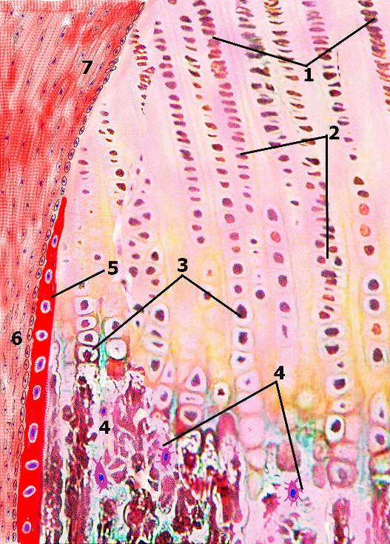

Fig. 5.26

As haversian systems are resorbed, their osteocytes die; in addition, osteoclasts are recruited to the area to resorb the bone matrix, forming absorption cavities. Continual osteoclastic activity increases the diameter and length of these cavities, which are invaded by blood vessels. At this point, bone resorption ceases and osteoblasts deposit new concentric lamellae around the blood vessels, forming new haversian systems. Although primary bone is remodeled in this fashion, which strengthens the bone by ordered collagen alignment about the haversian system, remodeling continues throughout life as resorption is replaced by deposition and the formation of new haversian systems. This process of bone resorption, followed by bone replacement, is known as coupling. The interstitial lamellae observed in adult bone are remnants of remodeled haversian systems. Bone Repair. Bone repair involves both intramembranous and endochondral bone formation. A bone fracture causes damage and destruction to the bone matrix, death to cells, tears in the periosteum and endosteum, and possible displacement of the ends of the broken bone (fragments). Blood vessels are severed near the break, and localized hemorrhaging fills in the zone of the break, resulting in blood clot formation at the site of injury. Soon the blood supply is shut down in a retrograde fashion from the injury site back to regions of anastomosing vessels, which can establish a new circulation route. As a consequence there is a widening zone of injury, on either side of the original break, resulting in a lack of a blood supply to many haversian systems, thus causing the zone of dead and dying osteocytes to increase appreciably. Because bone marrow and the periosteum are highly vascularized, the initial injury site in either of these two areas does not grow significantly, nor is there a notable increase in dead and dying cells much beyond the original injury site. Whenever the bone's haversian systems are without a blood supply, osteocytes become pyknotic and undergo lysis, leaving empty lacunae.

